The Human Rights Complaint Process:
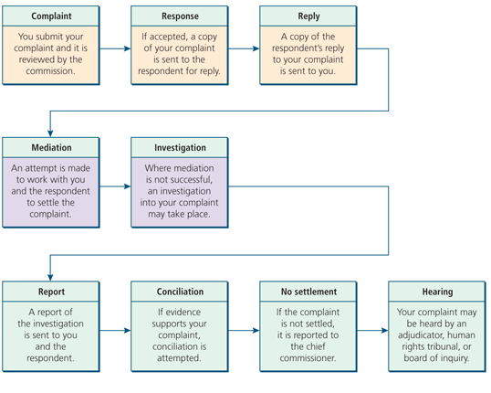
Human Rights Case Study:
Put yourself in the position of the individual being discriminated against. Answer the questions that follow in complete sentences.
Tim was eighteen years old, and legally an adult. He decided that he wanted to move out of his parent’s house. He had been considering this for some time, and had a part time job, and money saved in order to pay for a place of his own. He searched the classified section of the newspaper and found an add for a one-bedroom apartment, in a neighbourhood close to the local college, where he would be attending classes in the fall. He called the number and scheduled a viewing. Tim arrived at the viewing ten minutes early with his mom. When the landlord approached them, he was only interested in speaking to Tim’s mother. He assumed that she was the one who responded to the advertisement. Throughout the entire viewing, the landlord seemed extremely positive, and at the end he was ready to sign the lease. When it came time to fill out the form and pay the first and last months rent, Tim stepped up and attempted to sign the lease. The landlord asked if Tim was the one who would be renting, and when Tim said he would be, the landlord took the forms back. When Tim asked if there was a problem the landlord stated “its my policy not to rent to anyone under the age of twenty-five.” When Tim said he had proof he could both afford the apartment and references to back up his character. The landlord said it did not matter, and that there was no way Tim would be able to rent the apartment.
Has Tim been discriminated against?
- What would his first step be to take action based on discrimination?
- What form of discrimination is Tim experiencing?
- Who could Tim contact for legal information, concerning human rights in Ontario?

- If Tim’s complaint was verified by the Ontario Human Rights Tribunal, what would the process look like?
Step One:
Step Two:
Step Three:
Step Four:
Step Five:
- What would be a realistic conclusion to this case?

