BOOM TIMES:

For much of the 1920s, the Canadian economy was in a boom. In this type of economy, there are increases in the production of goods and services. These increases lead to a greater demand for workers and an increase in employment. With more employment, workers have more money. With more money, there is an increased demand for goods and services - a situation that leads to higher prices. Some called the period “the Roaring Twenties.”

During the 1920s, there was a general feeling of optimism about the economy. Business leaders, bankers, and workers believed that things could only get better and better. As a result, many borrowed money to expand factories and to buy new consumer products.

THE STOCK MARKET:

If a company, such as Radio Corporation of America (RCA), offered 1000 shares for sale on the stock market, you could purchase one share for $10 or ten shares for $100. The price of the share or the stock was determined by demand. If many people wanted or demanded the stock, the price would go up. If people did not want the stock (low demand), the price went down.

During the 1920s, the price of many stocks moved dramatically upward. For example, people wanted radios, and therefore the price of RCA stock moved up and up and up. RCA sold for $11 a share in 1924 and skyrocketed to $114 by 1929.

People bought RCA at one price and sold it a week later at a higher price and therefore made a profit. This seeking after profits drove the stock even higher.

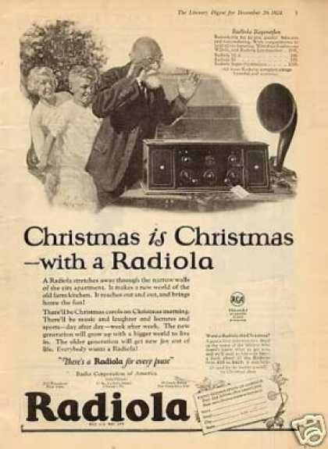

THE STOCK MARKET CRASH OF 1929:

Some say that what goes up has to come down. RCA and other stocks did come down on October 29, 1929, the day the stock market crashed in New York. At the same time, the big stock markets in Toronto and Montreal also crashed downward.
By this time, many people realized that RCA (and other stocks) were over-priced. In the case of RCA, people also realized that most families had a radio and that the company was facing slower sales in the future.

Once the selling of RCA stocks started, it grew into a panic. Within weeks the price of a share dropped from over $100 to $2. Similar activity happened with other stocks in Canada and the United States. For example, Massey-Harris Farm Machinery dropped from $100 a share to $2.50.

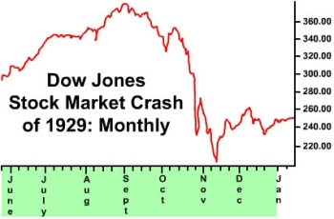

During the Great Crash of 1929, tens of thousands of people lost their money in the stock market as the stocks plunged in price. Hundreds of thousands lost their jobs as factories closed. The stock market crash is the most visible sign of the end of the boom of the twenties and the start of the depression of the 1930s.

THE STOCK MARKET IN MODERN TIMES:

In modern times, stocks can still become overvalued and crash. For example, Nortel, a Canadian company that produces Internet and other communications technology, saw its stock prices rise dramatically to $124 a share in 2000. By October 2002, the stock had crashed to a low of 69 cents a share.

Like many companies in the 1920s, Nortel produced more equipment than it could sell. Furthermore, the directors of the company withheld information from the shareholders (owners) about the true state of the company. The fall of Nortel in 2002 did not create a depression in Canada, because other parts of the economy were strong.
CAUSES OF THE GREAT DEPRESSION:

To be depressed means to feel down. In an economic sense, a depression means a downturn in economic activity. The period from 1929 to 1939 is known as the Great Depression. The stock market crash was not the only cause of the Great Depression.

High Tariffs
For years, Canada and other countries had been producing too many goods and placing tariffs on imports (goods coming to Canada from other countries). A tariff is a tax on goods coming into the country. For example, Canada placed tariffs on farm machinery. The tariff made the foreign farm machinery more expensive and encouraged the Canadian farmers to buy machinery made in Canada by Massey-Harris.
This seemed like a good idea to protect Canadian industry and Canadian workers. The trouble was that other countries thought that tariffs were a good idea also. So, other countries used tariffs to keep out Canadian goods.
Therefore, Canada had great difficulty in selling its lumber and wheat because foreign tariffs made these products too expensive for people to buy in other countries. In general, high tariffs slowed down trade in the period of the Great Depression.

- Natural Disasters
Another cause of the Great Depression was natural disasters. These took place mainly in Western Canada and the United States. A lack of rain, high summer temperatures, and wind turned large sections of these regions into what were known as “dust bowls.”

Many farmers were not ready for the heat, wind and lack of rain. They had not secured their land by crop rotation and wind breaks. They lost much of their top soil when it dried in the hot temperatures and blew away in the strong winds. Many farmers went bankrupt, as they were unable to raise crops in the terrible conditions. About one quarter of the wheat farms on the Prairies were abandoned in the 1930s.

The Multiplier Effect

The problems faced by the Western farmers had what is called a “multiplier effect.” In other words, the farmers’ problems multiplied into other problems. Since many farmers could not send their wheat to market, workers on the railroads lost their jobs. Since farmers did not have income, they could not buy farm machinery, and therefore workers in the production of farm machinery lost their jobs.

In general, because workers did not have money, they could not buy new clothes or vacuum cleaners; therefore, the workers who produced new clothes and vacuum cleaners lost their jobs. Thus the multiplier effect continued! By 1933, one million Canadian workers were without jobs, about 30% of the labour force.

Lack of Government Response

Lack of proper government response was another cause of the Depression. As we will see in a later lesson, the government essentially did very little to stop the “multiplier effect” and, as a result, the Depression continued for 10 years.

Comprehension Questions:
- During the 1920s, why did many people borrow money?

- Why, during the 1920s, did the value of many stocks move upward?

- Which economic event signals the end of the strong economy of the 1920s and the beginning of the depressed economy of the 1930s?

- What is a tariff?

- How do environmental issues make the difficult circumstances of the 1930s even worse?

- How does the response of the government to the Great Depression worsen the situation?

