What is Valour Road?

The Victoria Cross is the highest military decoration awarded for valour "in the face of the enemy" to members of the armed forces of various Commonwealth countries.

The VC was introduced on 29 January 1856 by Queen Victoria. Since then, the medal has been awarded 1,358 times to 1,355 individual recipients. It is still awarded today.

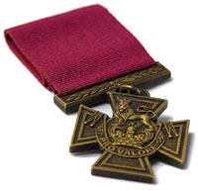

Valour Road is a street in the West End district of Winnipeg, Manitoba. It was originally called Pine Street but was renamed Valour Road in 1925 to recognize of the courage of three young men who lived in the 700 block and served in the First World War. Corporal Leo Clarke, Sergeant-Major Frederick William Hall, and Lieutenant Robert Shankland each received the Victoria Cross for acts of bravery during the war. Shankland was the only one to survive the war; the other two men were awarded the medal posthumously. All three medals are now on permanent display at the Canadian War Museum.

Click here to view the Historica “Valour Road” video.

