Saturnalia

Ancient Romans celebrated “Saturnalia”, a festival in which slaves and their masters would switch places.

It was held on the 17th December and later expanded with festivities through to 23rd December. The holiday included parties, a public banquet, and private gift giving. During this time, Roman societal norms were often overturned. For instance, gambling was permitted. The poet Catullus called it “the best of days”.

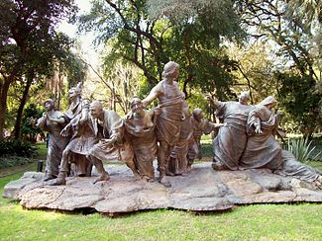

Saturnalia by Ernesto Biondi (1909), in the Buenos Aires Botanical Gardens

