Arts and Leisure:
In 1908, Lucy Maud Montgomery published the much-loved novel Anne of Green Gables, a rural romance set in Prince Edward Island.
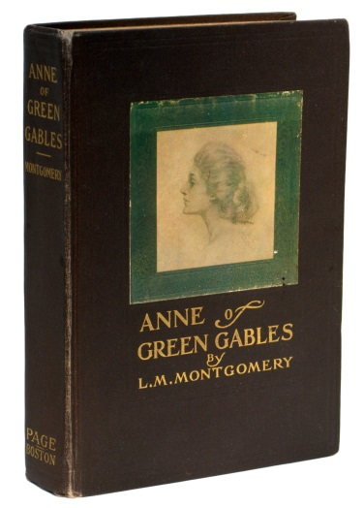
Above: A First-Edition Copy of Anne of Green Gables
Click to read the story “Why Anne of Green Gables is Big in Japan”

