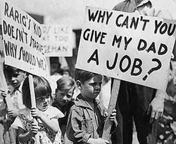
The Stock Market Crash:
In the latter half of the 1920s, the North American economy was booming, and Canadians were optimistic about the future. Like the United States, Canada had watched its industrial base expand during the war. It was now poised to overtake Europe, along with the United States, as an industrial leader.
However, the prosperity was quickly coming to an end. On Tuesday, October 29th, 1929, the New York Stock Exchange collapsed. On that day, prices of all stocks fell dramatically. The order of traders was to “sell, sell, sell!” More than 16 million shares changed hands, but prices continued to fall. Everyone knew a disaster had occurred.
The stock market crash marked a shift from the prosperity of the 1920s to the crushing poverty of “The Great Depression” of the 1930s.

