Ikea 'Deeply Regrets' Using Forced Prison Labor In East Germany

By Dan Fastenberg

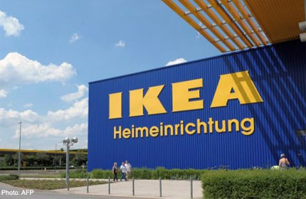

The country no longer exists; and the employer's crime happened decades ago. But in the court of public opinion there is no statute of limitations when it comes to the illegality and immorality of using forced prison labor. It's a lesson that Swedish furniture manufacturer Ikea is learning the hard way.

On Friday, Ikea issued a formal apology for using furniture components that were manufactured by political and other prisoners in the former East Germany in the 1980s. The revelation that the company used prison labor was disclosed in a report by the auditors Ernst & Young. The report said that many employees at the furniture giant suspected that forced prison labor was possibly being used, and they raised concerns about the possibility.

"We deeply regret that this could happen," Jeanette Skjelmose, sustainability manager at Ikea, said in a statement. "The use of political prisoners in production has never been acceptable to the Ikea Group." The prisoners were opponents of the East German regime, which was then part of the Soviet Bloc during the Cold War.

Ikea said it will donate money for research projects on forced labor in the former East Germany. (East Germany was dissolved in 1990 as it reunited with West Germany after the Cold War ended.)

The allegation that Ikea used prison labor was raised as far back as 1982 by human rights groups in Sweden, according to The Associated Press. But the airing last year of a Swedish television documentary on the subject reignited public interest. In response, Ikea commissioned a report by Ernst & Young in May, according to The New York Times.

The report detailed the situation that made possible the use of the political prisoners. Facing a labor shortage in the 1980s, Ikea turned to state-owned companies based out of East Germany, which formally known as the German Democratic Republic.

In choosing its workers, "the G.D.R. did not differentiate between political and criminal prisoners," Ernst & Young wrote in the report. "During this time period, many innocent individuals were sent to prison," the report also said.

At the time, Ikea did have safeguards against the use of forced labor. But visits by Ikea employees to production sites in East Germany were heavily monitored by the East German government, and were only allowed to take place in certain parts of production plants.

Regardless, several employees at Ikea expressed concerns about the possible use of forced labor in producing the components. But no action was taken.

"At the time, we didn't have today's well-developed control system and obviously didn't do enough to prevent such production conditions among our former G.D.R. suppliers," Ikea also said.

For human rights advocates, the experience is not being seen as unique to just one company operating in East Germany.

"Ikea is only the tip of the iceberg," Rainer Wagner, chairman of the victims' group UOKG, told The Associated Press. Wagner is also calling for reparations to be paid directly to the victims.

