The Story of Keep Calm and Carry On:

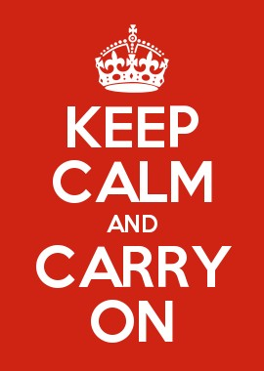

On the eve of WWII, the British government printed 2.5 million Keep Calm and Carry On posters. The aim of this simple five-word statement was to convey to the country a message of reassurance for the troubled times that lay ahead.
The posters went unused and subsequently were destroyed at the end of the war. Some sixty-five years later, a second-hand book dealer in the North of England discovered a copy of the poster in a box of books bought at auction. That find marked the rebirth and launch of the Keep Calm and Carry On message into the twenty-first century.

