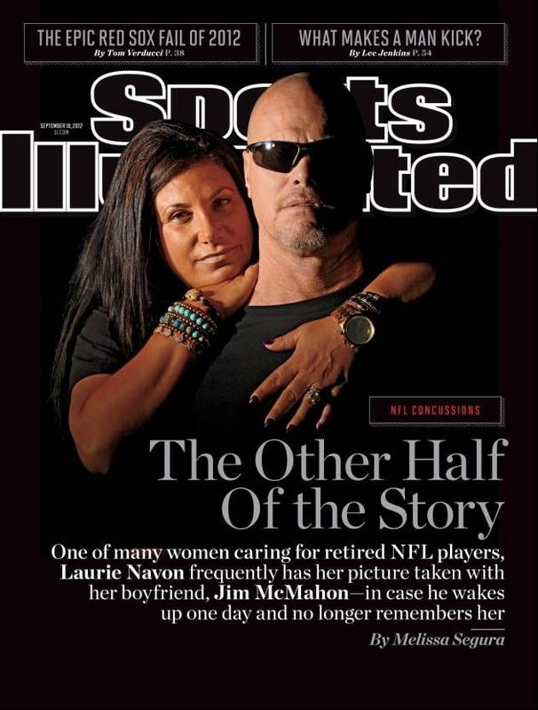

By Melissa Segura
September 10th, 2012

The notebook is pink and purple, his favorite colors. His girlfriend picked it up at a Phoenix-area store eight months ago. She shuttles it between their home office and a desk in their kitchen, jotting down things she knows her fifty-three-year-old boyfriend, two-time Super Bowl-winner quarterback Jim McMahon, won’t remember.

May 28, 2012 Told JM about golf out in Mississippi for [country musician Steve] Azar. From Azar's heading to Mario's [Lemieux] event.

A few pages later:

On 6/5 told Mac we need to start to get organized for Azar's event and for Mario's. Looked at me like I have five heads. And he said, "I didn't think we were going to Azar's." After a few minutes, he looked at me and said, "Baby, you're right. Sorry. I forgot."

Laurie Navon started the log to help McMahon, who played for the Bears and six other NFL teams between 1982 and '96, recall everything from which charity golf events he was scheduled to attend to why the plumbers were at the door. (Plumber was here. Said we need to change our two toilets.) Many of the other wives and girlfriends who care for retired professional football players—who, according to a 2009 University of Michigan study, may be five times more likely than other men their age to suffer from dementia—can relate to Navon's log. Its details might be unfamiliar, but overall it tells a familiar story. Theirs.

Navon, 46, is part of an unofficial sorority whose members meet at the occasional team reunion dinner or charity golf tournament. They recognize each other by the burdens they share and by the familiar characteristics of their mates: the slow shuffle, the empty stare, the non-sequitur replies to simple questions. Like Junior League members swapping recipes, the women trade tips for managing their partners' memory loss and mood swings.

Over the course of the last year, more than 140 lawsuits have been filed by players and their families against the NFL alleging that the league had concealed information about the dangers of repeated blows to the head.

The damages the plaintiffs allege include "loss of consortium," a nebulous legal phrase that really means a life tethered to a cellphone for fear of missing a call from a confused partner who is standing outside a house he no longer recognizes; a sense that the couples' golden years have been taken away; and, for some of the women, a daily dose of antidepressants to help them withstand their partners' senseless rage.

These women are not only their partners' caretakers but also their voices and advocates. They led the fight for the NFL 88 Plan, a fund to help families pay for the care of former players with dementia. They have testified before Congress about the dangers of concussions. And they have served as the primary contacts for lawyers representing the former players in their battle with the league.

Two years ago Laurie Navon would walk into the bedroom of the Scottsdale house she shares with McMahon and find him lying on the bed watching the ceiling fan go round and round. He slept so much—"hibernating," she joked—that she began to call him This Old Bear, not knowing that he was showing the first signs of dementia. When he did get out of bed to go to the mailbox or the hardware store, McMahon would kiss Navon goodbye, but 20 minutes later she'd find him in the kitchen, keys still in hand, struggling to remember where he wanted to go. Then there were the times he'd get up, stumble on something and accuse Navon of having rearranged their furniture in the middle of the night. Or the morning on the road when she woke up in the hotel bed to hear McMahon calling out for their Doberman, "Teddy. Teddy." When she rolled over to ask why, he told her, "Teddy will guide me to the bathroom."

"But we're not home," she said.
He looked around blankly. "That's right," he said.

McMahon today differs dramatically from the man Navon met at a golf tournament in Florida seven years ago. "I fell in love with him the minute I met him," she says. "There was something charismatic about him. He sparkled. He glowed. He was sweet and confident and funny and warm and compassionate. Total opposite of everything I'd ever heard about him." That glow began to dim after an event for McMahon's foundation before the Super Bowl in 2009. "That was the last time I saw Jim light, not heavy," Navon says. "Sometimes it looks like the weight of the world is on his shoulders."

Navon dismissed McMahon's early symptoms as normal aging until 2007, when, on the eve of the Super Bowl, she caught a TV special featuring a discussion of brain trauma by Ann McKee and Chris Nowinski of the Sports Legacy Institute in Boston. Shortly after that program Navon called Nowinski to say, "I think Mac's got some serious issues going on."

Brain scans and other tests recommended by Nowinski confirmed that McMahon was suffering from early-onset dementia, a condition the couple connects to the four documented concussions that McMahon suffered during his 15-year career, including a 1986 season-ending body slam by Green Bay's Charles Martin. That year a Chicago Sun-Times story had predicted facetiously that McMahon would one day wear the phrase BRAIN-DAMAGED on his famous headbands. His diagnosis turned that joke into a grim reality.

These days Navon and McMahon play backgammon to keep his mind active. She printed a card with his vital statistics and her phone number and stuck it in his wallet lest he ever get lost. She also programmed their car's GPS with their address and her phone number. Navon makes sure the home alarm is on at all times in case he tries to wander off alone, and she tries to travel with him as much as possible—especially since he called her four years ago after accidentally boarding a flight to Tampa instead of Chicago. She has their picture taken frequently, in case he wakes up one day and no longer remembers her.

"He could stay like this for the next 20 years, which I would take," Navon says. "I can handle it." But in recent months Navon has noticed a new symptom in McMahon. He drops to his knees, breaks into a cold sweat and turns a ghostly white, complaining of a pain that he compares to having an ice pick in his brain. It lasts a minute. All Navon can do is watch.

Analysis Questions:

- Why does Laurie Navon keep a notebook for her boyfriend, former Chicago Bears quarterback Jim McMahon?
- Explain the sentence: “These women are not only their partners' caretakers but also their voices and advocates”.
- What do Navon and McMahon learn through their meeting with Chris Nowinski?

