Canada Declares War:
On September 1st, 1939, Germany invaded Poland. Two days later, Britain and France declared war on Germany. In the First World War, when Britain declared war on Germany, Canada was automatically at war. But, in 1939, Canada was an autonomous country with no such obligation. Prime Minster Mackenzie King knew that once Britain became involved in such a major conflict, Canada would almost certainly support it, but the decision to join the war had to be a Canadian one, decided by Canada’s parliament.
Parliament Votes For War:
On September 8th, King called a special session of parliament to decide whether Canada would join the war. His Minister of Justice, Ernest Lapointe from Quebec, also spoke in favour of the war. But Lapointe spoke bluntly about what conscription would do to Liberal supporters in Quebec: “I am authorized by my colleagues in the Cabinet in Quebec, to say that we will never agree to conscription and will never be members or supporters of a government that will try to enforce it.” This statement helped win support for the war in Quebec and convinced voters that Canada’s involvement was necessary. Conscious of how conscription had divided the country during the First World War, King assured Parliament, and Quebec, that “so long as this government may be in power, no such measure (as conscription) shall be enacted.”
King’s position on joining the war was supported by the opposition Conservative party. Only J.S. Woodsworth, the leader of the Co-operative Commonwealth Federation, argued against going to war. He believed that nothing could be settled by war, and he tried to convince the government that Canada should remain neutral. But Woodsworth did not find support for his pacifist position, and Parliament voted in favour of going to war. On September 10th, 1939, Canada declared war on Germany.
Mobilizing Canada’s Resources:
Despite its willingness to join the war, Canada was not prepared for it. Its armed forces were small and unfit for combat. The Canadian army had only 4300 troops, a few light tanks, and no modern artillery. The air force and the navy were small with outdated equipment.
Unlike the First World War, there were no crowds cheering on the streets when Canada declared war in 1939. Many Canadians vividly remembered the horrors of the last world conflict. Still, Canada had no trouble finding volunteers. In September 1939, more than 58,000 people volunteered for service. The Canadian army initially rejected African-Canadian volunteers because of racist attitudes. As the war continued, however, African-Canadians were encouraged to join the regular army and officer corps. As in the First World War, Aboriginal peoples volunteered at a higher percentage than any other group in Canada.
Many people still felt strong ties to Britain and volunteered from a sense of duty. Others were driven by a sense of new-found national pride. After years of economic hardship, some Canadians were attracted by the luxury of a steady income. The first Canadian troops sailed from Halifax on December 10th, 1939.
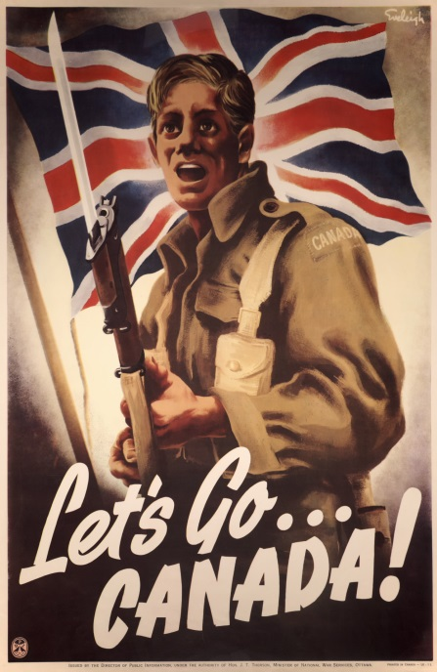
Above: A Canadian Recruitment Poster
The British Commonwealth Air Training Plan:
Mackenzie King hoped that Canada’s contributions to the war effort would be mostly supplies and training, rather than troops. In December 1939, Canada agreed to host and run the British Commonwealth Air Training Plan (BCATP). Pilots and other flight personnel from all over the Commonwealth came to Canada to train with British instructors. Airfields were built on the Prairies and in other locations near small towns and villages. Old aircraft were refitted and were returned to service for training purposes. The program was a major Canadian contribution to the war effort. The BCATP trained more than 130,000 pilots, navigators, flight engineers, and ground crew. The total cost was more than 2.2 billion, of which Canada paid than 70 percent. Contrary to King’s hopes, however, Canada’s role in the war went far beyond its involvement in the BCATP.
Total War:
The demands of total war meant that the federal government became more involved in planning and controlling the economy. In April 1940, the Department of Munitions and Supply was created and industrialist C.D. Howe was put in charge. Howe was given extraordinary authority to do whatever it took to gear up the economy to meet wartime demands. He told industries what to produce and how to produce it. He convinced business leaders to manufacture good that they had never made before. Soon, Vancouver was building ships for the navy. Montreal was constructing new planes and bombers. Canada’s car industries were producing military vehicles and tanks. Munitions factories opened in Ontario and Quebec. If the private sector could not produce what Howe wanted, he created Crown Corporations to do the job. Even farmers were told to produce more wheat, beef, dairy products, and other foods. Under Howe’s leadership, the government ran telephone companies, refined fuel, stockpiled silk for parachutes, mined uranium, and controlled food production. Some people referred to C.D. Howe as the “Minister of Everything”.

Analysis Questions:
- How is Canada’s entry into WWII different from its entry into WWI?

- What is significant about this difference?

- What concerns does the Quebec government have as WWII begins?

- How is the public reaction to the beginning of WWII different from its reaction to the beginning of WWI?

- As WWII begins, how does Prime Minister King hope that Canada’s contribution will look?

- Comment on the truth of the following statement: “had his voice been heard, J.S. Woodsworth would have been responsible for the death of millions more people than did, in fact, die during WWII.”

- Infer why “Mackenzie King hoped that Canada’s contributions to the war effort would be mostly supplies and training, rather than troops”.

- Infer how the BCATP impacts the world in the decades following WWII.

- In what ways can C.D. Howe be seen as a Canadian hero of WWII? In what ways can he be seen as a tyrant?

