“The Crucified Soldier”:
Was “The Crucified Canadian Soldier” a true story of the atrocities of the First World War, or just war propaganda?
It began in July, 1915, with a note written by a British nurse, Ursula Violet Chaloner, detailing the comments made to her by Lance Corporal C.M. Brown about a Canadian solder, a Sergeant Harry band, who was crucified on the door of a barn with bayonets at The Second Battle of Ypres.
One story indicates that on April 24th, 1915, a young sergeant with maple leaves on his lapels was found suspended 18 inches from the ground crucified to a barn door with bayonets.
Many speculated that the Canadian soldier was Sergeant Harry Band, who on April 24th, 1915, was reported missing in British military records and presumed dead. The records also show that Sergeant Band’s regiment, the 48th Canadian Highlanders, was fighting near St. Julien.
Two days before Sergeant Band’s death, Germany launched a gas attack on the Canadian, French, and Algerian army, while they were having breakfast, killing more than 5,000 men. The attack broke the international rules of warfare. In retaliation, Canadian troops killed German prisoners. It is thought the Germans crucified the Canadian soldier as a warning.
In 1918, Francis Derwent cast a bronze image of the crucifixion and it is called “Canada’s Golgotha”. After the war, the sculpture was put on exhibition at Ypres but was removed when Germany objected. It was warehouse for more than sixty years. It is now on display at the Canadian War Museum.

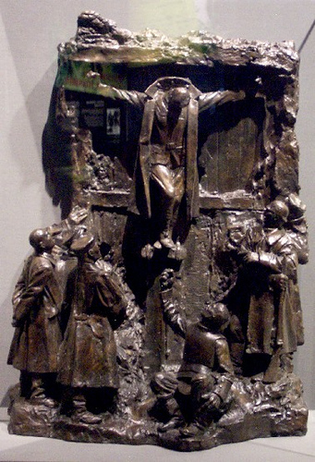

But, is the story true?
There was no conclusive proof such a crucifixion actually occurred. The eyewitness accounts were somewhat contradictory, no crucified body was found, and no knowledge was uncovered at the time about the identity of the supposedly crucified soldier. During World War Two, the story was used by the Nazis as an example of British propaganda.

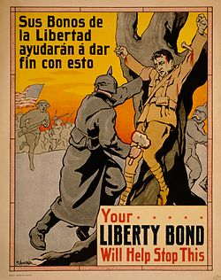
Above: An American propaganda poster from the Philippines depicting the crucified soldier.

