Pearl Harbour and Hong Kong:
Japan began a campaign to expand its territory in the 1930s. By 1941, it was prepared to invade American and European colonies in Southeast Asia to gain control of valuable resources such as oil, rubber, and tin. Japan knew such action would almost certainly involve the United States, which had thus far remained neutral in the war.
Japanese strategy depended on a quick and decisive strike against the United States. In a surprise attack on December 7th, 1941, Japanese planes bombed the U.S. naval base in Pearl Harbour, on the island of Hawaii. More than 2,400 people were killed and much of the American fleet was destroyed. Japan then bombed the U.S. territory of the Philippines.
The surprise bombings stunned the Americans. On December 8th the U.S. joined the Allies and declared war on Japan. Japan’s allies – Germany and Italy – then declared war on the United States. The whole world was now at war.

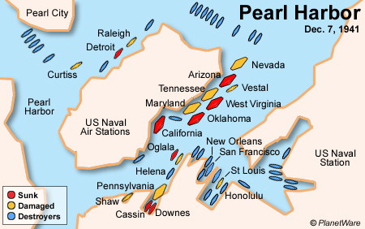

Battle of Hong Kong:
Only hours after bombing Pearl Habour, Japan attacked Hong Kong, a British colony at the time. Weeks earlier, Canada had sent two battalions, from Winnipeg and Quebec, to reinforce the British and Commonwealth forces in Hong Kong. The Canadians were inexperienced and the 20,000 Allied soldiers were no match for the skilled Japanese soldiers. After eighteen days of bitter fighting, Hong Kong fell to the Japanese on what would become known as “Black Christmas”, December 25th, 1941. Every Canadian was killed or taken prisoner.
Nearly 1700 Canadian prisoners of war faced brutal conditions and were later used as slave labour. More than 260 of these POWs died during three-and-a-half years of imprisonment. Canadians at home were horrified to learn the fate of the soldiers and angry that troops had been sent to Hong Kong. The Japanese treatment of Allied troops may have encouraged the anti-Japanese sentiment that culminated in the internment of Japanese-Canadians.

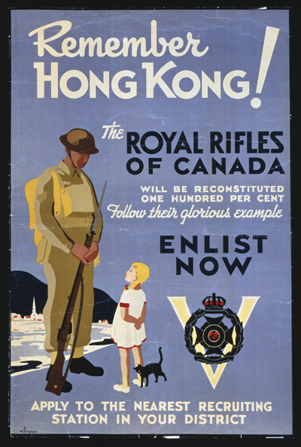

Infer: What is the message of this poster?
Analysis Questions:
- Why did the Japanese attack the U.S. navy at Pearl Harbour? How did this attack change the course of the war?

- Why would Canada send troops to Hong Kong? Why were Canadians angry when they learned the fate of troops in Hong Kong?

