Creative Story:

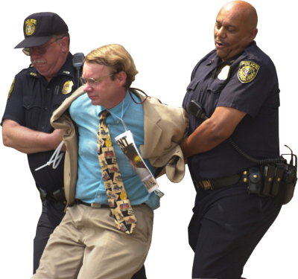

Your task is to:
- You are to create a story based on the picture above.
- It must include a title and the names of characters
- You must incorporate the following terms/words into your story.

Arrest
Detention
Appearance Notice
Bench Warrant
Search Warrant
Line Up
Fingerprinting
Surety
Bail
Indictable Offence

- Your story should have a clear narrative structure, meaning that it needs a beginning, a middle, and an end.

- If you are unsure of the meaning of one or more of the words, a quick Internet search will help quite a bit.

Guidelines:
- Assignment is to be typed
- It should be double-spaced
- The writing should be one page in length, with a maximum of two pages
- Include your name, date, and course in the top left hand corner

Creative Stories will be marked based on the following criteria:

 | Level I | Level II | Level III | Level IV
Does the story accurately apply key terms? | The story does not accurately apply key words | The story applies key words in a limited fashion | The story applies key words well | The story applies key words very well
Does the story offer a clear narrative structure? | The story does not offer a clear narrative structure | The story offers a somewhat clear narrative structure | The story offers a clear narrative structure | The story offers a perfectly clear narrative structure
Does the story demonstrate creativity? | The story does not demonstrate creativity | The story demonstrates creativity on a limited basis | The story demonstrates good creativity | The story demonstrates excellent creativity
Does the story show attention to detail? | The story does not show attention to detail | The story shows limited attention to detail | The story shows good attention to detail | The story shows excellent attention to detail

