MLK: “Before You Finish Breakfast …”

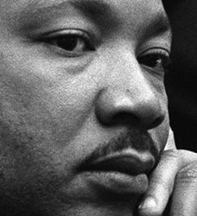

There was so much to admire in Martin Luther King -- his courage, his faith, and his humility all come to mind. But by any measure, one of his most remarkable traits was an ability to see the way life intersects, how each of us depends on a far-flung legion every day just to survive.
Today we hear plenty about globalization, supply chain integration, and the wired world. It all sounds original and modern.
Yet nearly 50 years ago, Dr. King had already seen it. On Christmas Eve in 1967, just a few months before his murder, he stood in the pulpit of the Ebenezer Baptist Church in Atlanta and described his profound vision.
In his 1967 Massey Lecture #5, also known as his "Christmas Sermon on Peace," Dr. King said:
It really boils down to this: that all life is interrelated. We are all caught in an inescapable network of mutuality, tied into a single garment of destiny. Whatever affects one directly, affects all indirectly. We are made to live together because of the interrelated structure of reality.
Did you ever stop to think that you can't leave for your job in the morning without being dependent upon most of the world? You get up in the morning and go to the bathroom and reach over for the sponge, and that's handed you by a Pacific Islander. You reach for a bar of soap, and that's given to you at the hands of a Frenchman. And then you go into the kitchen to drink your coffee for the morning and that is poured into your cup by a South American. And maybe you want tea: that's poured into your cup by a Chinese.
Or maybe you desire to have cocoa for breakfast, and that's poured into your cup by a West African. And then you reach over for your toast, and that's given you at the hands of an English-speaking farmer, not to mention the baker. And before you finish eating breakfast in the morning, you've depended on more than half the world.
This is the way our universe is structured. It is its interrelated quality.
We aren't going to have peace on earth until we recognize this basic fact of the interrelated structure of all reality.

