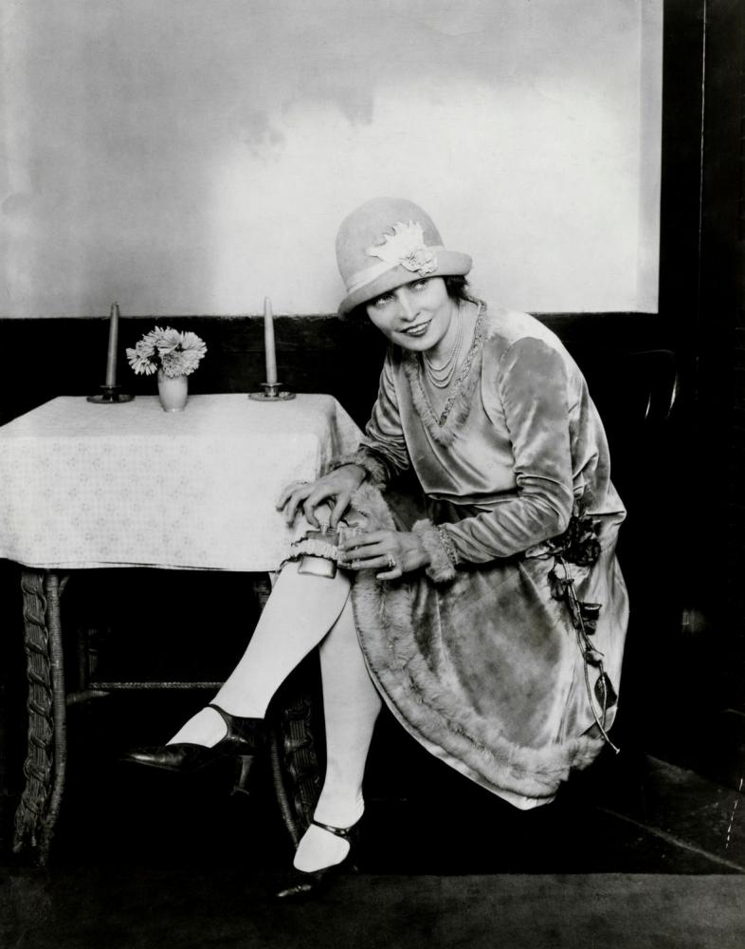
Photo Analysis:
- Describe what is happening in the photo.
- Infer the mood of the woman in the photo.

