Strange Canadian Laws:

It’s Illegal to Whistle in Petrolia, Ontario

A Petrolia city rep says this unusual law simply aims to limit excessive noise between 11 p.m. and 7 a.m., but according to Article 3, 772.3.6 on the town’s website, “Yelling, shouting, hooting, whistling or singing is prohibited at all times.”

Strange Canadian Laws:

Keep Your Booze at Home

According to the Importation of Intoxicating Liquors Act (which dates back to the time of prohibition), you can only legally move a bottle of booze from one province to another with the permission of the provincial liquor control board. The situation changed on May 28th, 2012, allowing you to legally move wine, but little else.

Strange Canadian Laws:

It’s Illegal to Attach a Siren to Your Bike in Sudbury, Ontario

Since 1973, the only noise-makers Sudbury cyclists can attach to their bikes are bells and horns. Breaking noise bylaws in Sudbury can lead to fines up to $5,000. Who attaches a siren to their bike, anyways?

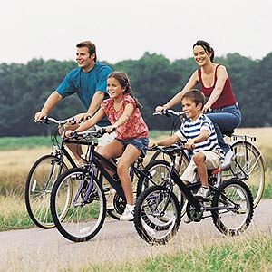

Strange Canadian Laws:

Taxi Drivers Can’t Wear a T-Shirt in Halifax, Nova Scotia

According to Halifax’s Regional Municipality Bylaws for Taxis and Limousines, number 42a) stipulates drivers must wear shoes and socks, keep their attire in neat and tidy condition at all times, and absolutely cannot wear a t-shirt.

Looks like summer is a whole lot hotter for cabbies in Halifax.

Strange Canadian Laws:

Province-wide, Alberta: It is against the law to paint a wooden ladder

126. “A person must not paint a wooden ladder.”

Strange Canadian Laws:
Province-Wide, Alberta: It is illegal to own a pet rat.

11-2. “A person shall not purchase, keep or sell live rats unless the person holds a permit issued under subsection.”
Alberta is the only region in the entire world free of Norwegian rats.

Strange Canadian Laws:

It’s Illegal to Build Big Snowmen in Souris, P.E.I.

Souris, P.E.I. is well-known to summer visitors for its curious ‘Singing Sands’ Beach, but few know of a local law that warns residents against building monstrous snowmen. If you live on a corner lot it’s against the law to build a snowman taller than 30-inches.

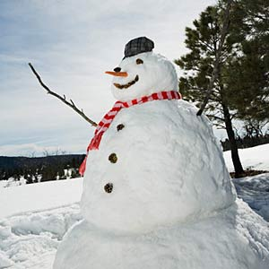

Strange Canadian Laws:

Get Your Margarine out of Here!

I remember this, and it’s okay that you don’t. Thanks to lobbying by dairy farmers it was illegal to sell butter-coloured margarine in Ontario until 1995. In fact, margarine was altogether banned in Canada from 1886 to 1948 (there was a brief reprieve during WWI).

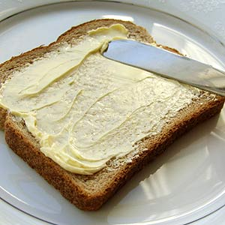

Strange Canadian Laws:

Keep Your Kids at Home in St. Paul, Alberta

St. Paul residents don’t have to worry about their kids sneaking out late at night. It’s against the law for anyone fifteen or younger to loiter in a public place without supervision of a parent or guardian between 12:01 a.m. and 6 a.m.

Strange Canadian Laws:

Toronto, Ontario: It is against the law to swear in a public park.

608-3. “While in a park, no person shall indulge in riotous, boisterous, violent, threatening, or illegal conduct or use profane or abusive language.”

Strange Canadian Laws:

Oshawa, Ontario: It is against the law to climb a tree.

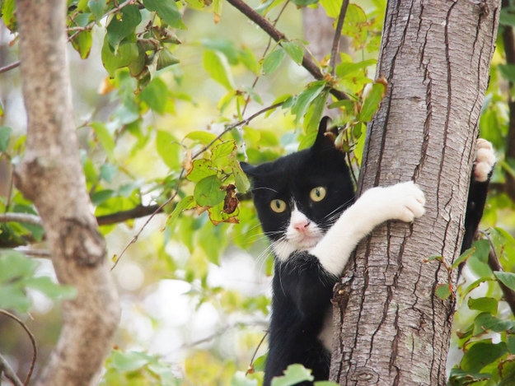

8.3. “No person shall interfere with a tree or part of a tree located on municipal property, including but not limited to attaching, affixing or placing upon in any manner any object or thing to a tree or part of a tree, and climbing the tree.”

Strange Canadian Laws:

Nation-Wide: It is Illegal to Pretend to Practice Witchcraft.

365. “Everyone who fraudulently pretends to exercise or to use any kind of witchcraft, sorcery, enchantment or conjuration is guilty of an offense punishable on summary conviction.”

Strange Canadian Laws:

Nation-Wide: It is Illegal to Create, Possess, and Sell Crime Comics.

163b. The Criminal Code of Canada has “makes, prints, publishes, distributes, sells or has in his possession for the purpose of publication, distribution or circulation a crime comic.” listed under the section titled Offenses Tending to Corrupt Morals.

Strange Canadian Laws:

Nation-Wide: It is Illegal to Challenge Someone to a Duel and/or Accept an Invitation to a Duel.

71. “Everyone who challenges or attempts by any means to provoke another person to fight a duel, attempts to provoke a person to challenge another person to fight a duel, or accepts a challenge to fight a duel, is guilty of an indictable offense and liable to imprisonment for a term not exceeding two years.”

Strange Canadian Laws:

Nation-wide: It is illegal to waterski after sunset.

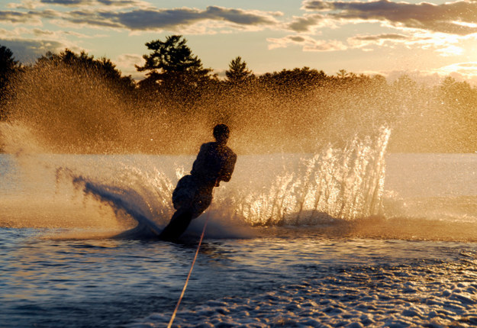

250. “Everyone who operates a vessel while towing a person on any water skis, surf-board, water sled or other object during the period from one hour after sunset to sunrise is guilty of an offense punishable on summary conviction.”

Strange Canadian Laws:

Nation-Wide: It is Illegal to Scare The Queen

49. “Everyone who willfully does an act with intent to alarm Her Majesty” is listed under the section Prohibited Acts in The Criminal Code of Canada.

