Henry Ford, Karl Marx, and You by Scott Roberts
15 September 2008

Throughout the tumultuous 20th century, American's of every economic class repeatedly rejected the ideology of Marxism. Why? Because of Henry Ford.

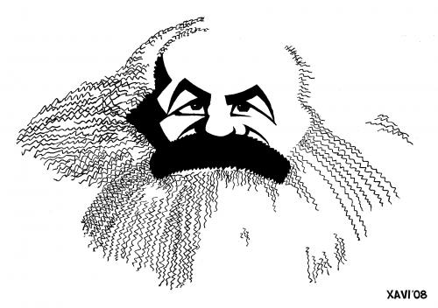

In 1914, Ford astonished the world by offering workers a $5 per day wage, more than double the rate of most of his workers.

The move proved extremely profitable; instead of constant turnover of employees, the best autoworkers flocked to Ford Motor, bringing their human capital and expertise, raising productivity, and lowering training costs. Ford was bitterly criticized by other industrialists and by Wall Street. However, Ford passionately believed that by paying a higher wage, not only would he manufacture a better car, he would also enable his workers to afford the cars they were producing, contributing to a more robust American economy.

Ford was first major industrialist to embrace the ideology of what became known as "welfare capitalism."

In his 1990 book 'The Three Worlds of Welfare Capitalism' author Gosta Esping-Anderson defines three different types of modern welfare states. There is the 'Social Democratic' Model, as exemplified by the Scandinavian countries; the 'Liberal' Model, often related to the USA, Canada, and Australia, and thirdly, the 'Conservative' Model best exemplified by Germany, France and Italy.

Ford's living wage took auto workers, whom Marx would have called the proletariat, and turned them into a type of worker Marx did not fully anticipate; the middle-class worker.

Marx saw the world as basically a struggle between the haves (the capitalist) and the have-nots (the working-class proletariat). He noted that other classes existed, but believed that as time (and capitalism) moved forward, these other relatively minor-sized classes would eventually disappear, and society would become stratified until only the two classes remained, which would then become more and more polarized as time went on.

Marx never anticipated America; a powerful western nation brimming with middle-class workers, managers and professionals, a nation where even industrial workers lived a life of prosperity; working forty-hour workweeks, owning their own home, having access to healthcare, retirement plans, and quality public education for their children. Most importantly, in America, class was fluid; any child could grow up and become a `doctor, a lawyer, a scientist or even a wealthy industrialist.

In 1929, with the collapse of the American stock market and the onset of the Great Depression, the future of America's middle-class workers was seriously threatened. President Franklin Roosevelt introduced Social Security, work programs, and additional labor law safeguards that helped lure workers away from the siren song of Marxist ideology.

Has history proven Marx wrong?

The wave of communist-based nationalism that swept the world during the 20th century has ebbed. Russian-style centralized economic planning has clearly been an abysmal failure. With China's turn to state-supervised market capitalism, the remaining Marxist states scattered across the world seem quaint holdouts of a long-past era. Today, it appears that American-style market-capitalism has successfully led to wealth being spread across the spectrum of American society.

Or has it?

Ford Motor Company is now in a life-and-death struggle to survive. The company has shrunk, workers have been laid off, pension funds are under-funded and the union healthcare programs are in disarray. The story is the same at many other traditional American industries. Henry Ford's vision for middle-class workers is failing.

The disparity between rich and poor has not been this great since just before the Great Depression. Today, The United States is the most economically stratified society in the western world.

The Wall Street Journal recently reported that the top .01% or 14,000 American families hold 22.2% of wealth, an extraordinary amount of national wealth in the hands of very few people.

The rest of us? The bottom 90%, or over 133 million families, holds just 4% of the nation's wealth. The data also shows that the top 300,000 Americans collectively enjoyed almost as much income as the bottom 150 million Americans. Per person, the top group received 440 times as much as the average person in the bottom half earned, nearly doubling the gap from 1980.

The middle-class is caught in the middle; the American dream slipping out of their reach. We are becoming a nation of rich and poor.

Karl Marx would not be surprised.

