Where Did The Peace Sign Come From?

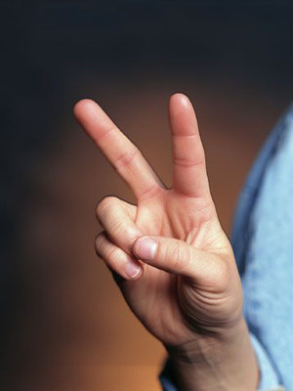

Legend has it that in the Battle of Agincourt in 1415 between the French, the French claimed they would cut off the arrow shooting fingers of all of the English soldiers. Unfortunately for them, the English would end up victorious and held up both of their arrow shooting fingers to show that they were still fully intact.

Originally the symbol was used as insult, first captured on film by an English worker in 1901 gesturing that he did not enjoy being filmed. The gesture had been known some time as insulting and passed down generation after generation. The main difference from the “peace sign” that we know today, however, is that the palm faced towards the body instead of out.

In 1941, during World War II, Victor de Lavaleye, a French speaking broadcaster for the BBC broadcasts in Belgium suggested that Belgians use V for *victoire,* victory in French, and *vrijheid,* freedom in Dutch, as a symbol for victory in the war.



The V caught on in Belgium, Netherlands, and Northern France and the BBC quickly adopted the “V for Victory” slogan for all of its broadcasts. The beginning of Beethoven's Fifth Symphony was then adopted as an intro for overseas BBC broadcasts; the opening bars being the same as the morse code rhythm for V, short-short-short-long. The great irony was that Beethoven was German, an irony not lost on most overseas visitors.

The BBC continued supporting “V for Victory” and the gesture, and it caught on. World War II Prime Minister Winston Churchill then began using it during speeches. Unfortunately, he started it as the widely recognized insulting gesture with the palm in, but quickly correct himself for later speeches.

The sign was later adopted by hippies and Vietnam protesters in the counterculture of the 1960s and is often now seen as the “peace sign” associated with that movement. In reality, the gesture has a much deeper history.

