Jean-Jacques Rousseau: Enlightenment Icon:

Jean-Jacques Rousseau was born on June 28th, 1712. He was born in Geneva. Rousseau was a philosopher and writer during the Enlightenment period.

Unlike most of the philosophes of his time, Rousseau did not enjoy the “salon circuit”’ of public speaking and appearances. A complicated, sensitive figure, Rousseau managed to rise from a very difficult childhood in Geneva to become a prolific catalyst for change, especially in the realm of social inequality. His most famous work, The Social Contract, harkened back romantically to a time past – one without the artificiality of the contemporary society he so loathed. In his view, a person’s existence was once noble, until tyrannical governments enchained human beings under the weight of crushing taxes and corrupt police, armies and laws. Property and privilege supplanted equality and personal freedom, and a bygone “Golden Age” was lost.

Rousseau’s solution was the formation of a society where the “general will” of the people was the basis of all decision making. The government was created to promote and protect the members of the state, operating under the principle that authority should rest on the consent of the governed.

Rousseau eventually died insane in a cottage at Ermenonville on July 2nd, 1778, from a sudden attack of thrombosis, which aroused suspicions of suicide. He was buried there until 1794 when his remains were placed with Voltaire's in Paris

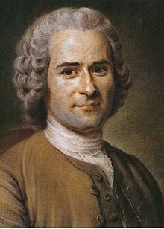

Rousseau in 1753, by Maurice Quentin de La Tour

