Roman Beauty Secret:
Women in Ancient Rome wore the sweat of Gladiators to improve their beauty and complexion.
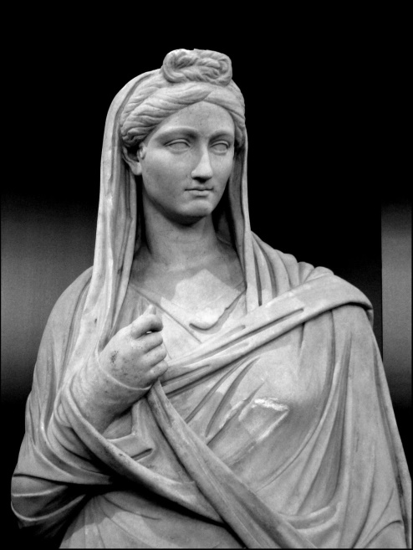
Above: A statue of Viba Sabina, circa 136 CE. She was the grand-niece of the emperor Trajan, and became the wife of his successor, Hadrian

