The Druids and “The Wicker Man”:

A Druid was a member of the educated, professional class among the Celtic peoples of Gaul, Britain, Ireland, and possibly elsewhere during the Iron Age (1200 BCE – 1 BCE).

The Druid class included law-speakers, poets and doctors, among other learned professions, although the best known among the Druids were the religious leaders.

Very little is known about the ancient Druids. They left no written accounts of themselves, and the only evidence are a few descriptions left by Greek, Roman, and various scattered authors and artists, as well as stories created by later medieval Irish writers.

Greek and Roman writers frequently made reference to the Druids as practitioners of human sacrifice, a trait they themselves reviled, believing it to be barbaric. Such reports of Druidic human sacrifice are found in the works of Strabo, a Greek historian, as well as Julius Caesar.

Regarding the Wicker Man, Strabo wrote that the Druids: “having devised a colossus of straw and wood, throw into the colossus cattle and wild animals of all sorts and human beings, and then make a burnt-offering of the whole thing.”

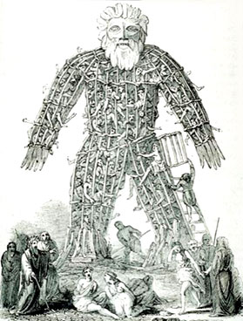

Most information on the Wicker Man comes from Julius Caesar, who states the Druids burned criminals and prisoners of war in the wicker structures, and that when such were unavailable, they “even go so low as to inflict punishment on the innocent”:

So did the Wicker Man really exist, or is it simply another ‘urban legend’ – a product of the classical imagination designed to reinforce the image of the savages in the popular psyche, and illustrate the necessity that they be ‘civilized’?

All classical accounts of the ‘Wicker Man’ and human sacrifice by burning were destroyed as heresay, and no eyewitness account has survived. Furthermore, no archaeological evidence of such a phenomenon has ever been discovered, which logically raises further doubts about the veracity of such claims.

And yet, there is one further source of information, produced by the Celts themselves, which may support the horrific accounts of ancient authors. During the first century BCE, various versions of Celtic coins depict a colossus with a burning head.

