Popular Films of the 1990s:

Computer imaging continued to change the way that films were made in the 1990s. Terminator 2: Judgement Day combined “live action” with computer animation in a way that had never been seen. Audiences were very impressed.

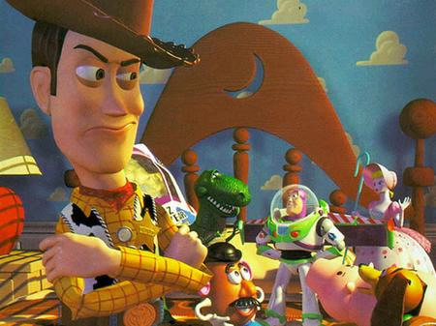
As the 1990s began, animated feature films began to return to popularity, in part because of the newer ease of use and availability of computers in animation. Disney released Beauty and the Beast in 1991, and it was very successful. Disney’s Aladdin, released in 1992, was also a huge hit. Toy Story was released in 1995, and it continued this trend.

In 1999, Star Wars Episode I: The Phantom Menace featured Jar Jar Binks, a character who was rendered completely digitally.

Hit films of the 1990s included Pretty Woman, Silence of the Lambs, Titanic, Pulp Fiction, Forest Gump, Braveheart, and The Matrix.

In 1991, about 3/4 of North American households had VCRs. DVD players first became available for sale in 1997. The VCR began to steadily decline in popularity due to the improved images, sound quality, and functionality of DVD players.

A scene from Toy Story

Popular Music of the 1990s:

As is the case in all decades, there was a wide variety of music in the 1990s. Grunge and country music explode in popularity during this decade. The grunge genre included artists such as Nirvana and Pearl Jam. Popular country artists of the 1990s included Garth Brooks and Travis Tritt.

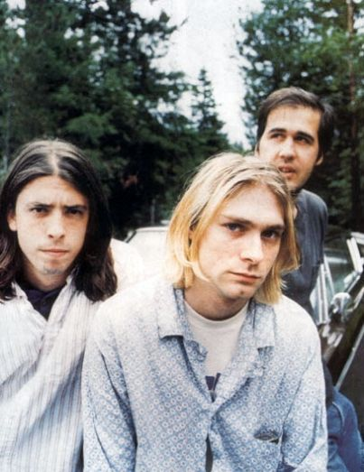
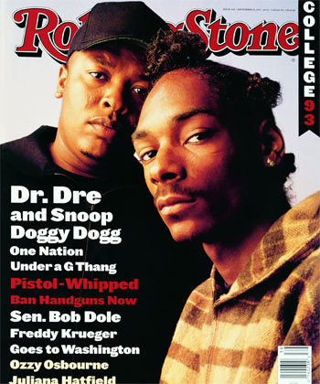


Music known as “pop punk” also emerged in the 1990s, led by Green Day and Blink-182. Female artists, including Ottawa’s Alanis Morissette, also had great success during the 1990s.

By the mid 1990s, hip hop music was selling as well as rock music in North America. Artists like Snoop Doggy Dogg, 2Pac, and Nortorious B.I.G. had sold well and had strong radio play.

Mariah Carey was named Billboard’s Artist of the Decade for the 1990s. She joined prior winners Elvis Presley, The Beatles, Elton John, and Michael Jackson.

From Left: Nirvana, Dr, Dre and Snoop Doggy Dogg, Garth Brooks, and Alainis Morissette

