Ancient Egypt and Chess:
Like the Mesopotamians, Egyptians were sociable people who enjoyed playing games. Board games were especially popular, including one called Senet, a racing game in which players tried to reach the realm of the gods. Senet is very similar to modern chess.
Another game called Snake used a snake-shaped board.
Other games familiar to us, such as backgammon, were also popular.
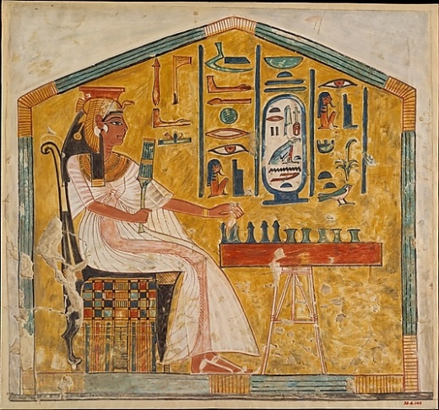
A wall painting from the Tomb of Queen Nefertari, the wife of Ramses II, depicting the queen playing Senet
Metropolitan Museum of Art

