Considering Decision Making:

In your group, look at one of the articles from the list below. Prepare to share with the class as a whole the following key information:

- Who is making the decision in this example?
- What is the decision in regards to?
- Who is impacted in the decision?
- How involved was the impacted party in the decision-making process?
- Do you agree with the decision made in your example? Justify your answer?

Here are the examples:

- The Near North District School Board Dress Code Policy
- Curfew for Teens Can Be a Handy Tool, Police Say
- Canadian Content Requirement for Music on Canadian Radio
- Schools Selling Ads, Raising Funds to Pay for Basics, Study Says

A Question of Ideology:

People have different views of how decisions should be made and who should make them. Some people believe that humans are naturally good and reasonably intelligent. As a result, they should be free to pursue their personal goals without too many rules. These people suggest that everyone should be involved in decisions of public importance.

Others are more distrustful of human nature. They suggest that people are naturally selfish and greedy, with only a limited ability to make public decisions. Therefore, society requires very clear rules and laws to ensure that discipline stay in the nation. Decision should be made by one person or by a very small group of people who have a better ability to lead.

Stop and Consider:

- What are two potential advantages and disadvantages of each of the models discussed in the two paragraphs below?

- Look back on the five examples at the top of this page. Now, look back at the two groups of people with differing views of human nature. How do you think each group might respond to the statement?

Are Humans Good or Evil?

Thomas Hobbes, a famous British philosopher in the 1600s, felt that all people are born selfish and will seek only their own interests. This selfishness often leads to violence and war. Hobbes thought people should be taught obedience, enforced by a supreme ruler, in order to avoid chaos.

A hundred years later, French philosopher Jean-Jacques Rousseau disagreed with Hobbes’s ideas and argued instead that the natural state of humans was one of peace and harmony. He saw democracy as a reflection of our basic sense of fairness and equality.

Analysis Questions:

- Do you agree with Hobbes or Rousseau?

- List three things you see in your life and in society that support either Hobbes or Rousseau. Discuss the photographs below as part of your evidence.

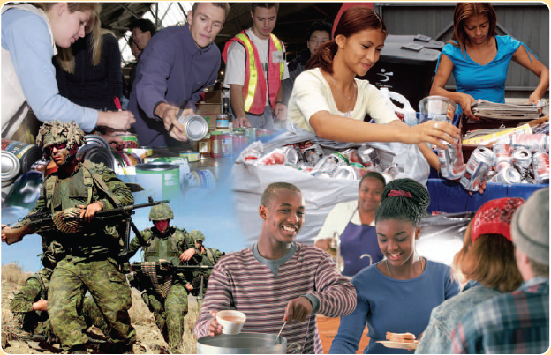

A Personal Decision-Making Strategy:

Think of a difficult personal decision that you made. How did you weigh the various sides of the issue? Were there other factors that influenced the way you arrived at your decision? What personal beliefs and values influenced the way you arrived at your decision? What person beliefs and values influenced the decision that you made? You probably discovered that the process of coming to an important decision was not an easy one.

Consider using the following steps before you make a decision:

Step I: Define the question, or issue to be decided

Step II: Identity your initial choice based on your personal goals and your understanding of the question at hand

Step III: Identify other possible options

Step IV: Explore and gather information about these possible options

Step V: Consider the pros and cons of your initial choice and the other possible options according to information available

Step VI: Choose the best alternative options and state your reasons

Step VII: Take appropriate action on your choice

Exit Card:

As your “ticket out the door” today:

- Think of an important personal decision that you have recently made.
  - How did you make your decision?
  - What factors influenced – and complicated – your decision?
  - What was the outcome?

