History’s First Vending Machine:
Heron of Alexandria created over a startling 80 inventions during his lifetime, and most of them relied on the properties of air and water.
One of the most fascinating? The first ever vending machine, created in the first century C.E.
This device was designed to prevent temple denizens from taking more holy water than they had purchased. Today, we use vending machines to acquire a never ending supply of mid-afternoon snacks, while Heron's holy water device along with several other "miraculous" inventions still amaze two-thousand years later.
A professor and one of the foremost Greek inventors of his era, Heron Alexandrinus (often referred to as Hero) spent his days teaching at the Museum in Alexandria, home to the Library at Alexandria, around 60 C.E.
Heron excelled in mathematics and engineering, creating of one of the first (if not the first) steam engines, the aeolipile.
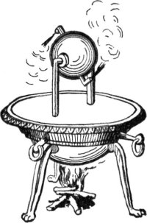
Stealing Holy Water:
Heron created the first vending machine not out of curiosity, but to stop temple thievery. Patrons of temples commonly took more holy water with them than they paid for — an early failure of the honor system.
To combat this, Heron created the first vending machine, that dispensed water blessed by the officials of the temple. By positioning a lever in the path of an external coin slot, a coin placed by a temple goer would rest against the lever, balancing on the lever until the coin eventually fell off. While the coin applied pressure on the lever, the holy water pours forth from an opened spout. Once the coin falls away, however, a counterweight is released by the movement of the lever and the water spout closes. A simple design, but it made sure no one took more than their allotted share of holy water.
Seven of Heron's books exist today, including Automata, which survived the centuries through translation into Arabic. Automata is an interesting collection, a work detailing how to construct "miracles" to bewilder and astonish temple goers. One of these devices automatically opened doors in temples by lighting a fire.

