London, Ontario: Home to Ontario’s First Mosque:

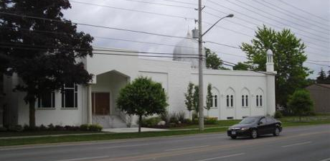
The London Muslim Mosque on Oxford St. West was the first purpose-built mosque in Ontario, the second in Canada, and third in North America.
Built over half a century ago, the LMM carries a rich history. Behind the attractive building lies a story of a group of dedicated individuals who sought to make London their home.
Hanny Shousher told and illustrated this story in Now and Then: An Historical Overview of the Muslim and Arab Communities of London, Ontario.
It all began around 1901, when a small group of Lebanese immigrants came to London. To help each other integrate, they started the Syrian-Lebanese Club. As Shousher explains, this club was non-political and non-religious. “Its aim was only to fulfill a mutual need for a sense of home and belonging.”
In the 1950s, the Canadian Moslem Benevolent Society (CMBS) was formed to find a common place of worship for London’s growing Muslim population, and, according to Shousher, “to establish a foundation of what would eventually become one of the most unified and active Muslim communities in Canada.”
Since they didn’t have an official place of worship, the newcomers regularly met to discuss what could be done for them, and for future generations.
In 1955, London hosted the fourth annual Muslim convention in North America. At the convention, the CMBS announced it was going to purchase property for a mosque. After much fundraising, the CMBS bought a house at 151 Oxford St. W. This was a milestone for the LMM.
A few years later, however, a tragic fire destroyed the mosque. In 1964, a new facility, which still stands today, was constructed on the same site with the help of generous donations from Muslims all over the continent.
Current estimates put London’s Muslim population as high as 30,000. It consists of immigrants from many countries as well as families who have lived here for generations.
Moving to a new country can be a struggle, and everyone takes time to adjust. The pioneers in this story have created a great stepping stone for London’s Muslims.
Shousher writes, “It is my hope that, knowing the valuable history of London’s Muslim and Arab communities, future generations will feel the same loyalty to our beautiful nation, our neighbours and our families, and continue the work started back in 1901.”

Citation:

- Wasty, Amna. "Ontario's First Mosque, Here in London, Laid a Foundation." The London Free Press. June 28, 2013. Accessed June 19, 2018. http://lfpress.com/2013/06/28/ontarios-first-mosque-here-in-london-laid-a-foundation/wcm/b98ad66a-7244-5dec-d15d-0242a4c0059b.

