The Iron Crown of Lombardy
By the 7th century, the Roman Empire had fallen in the West. During this era, the Iron Crown of Lombardy was constructed. The Iron Crown is so called from a narrow band of iron about one centimetre within it, said to be beaten out of a nail used at the Crucifixion.
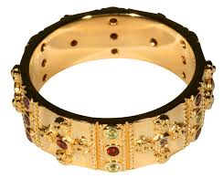
According to tradition, the nail was first given to Emperor Constantine – the first Christian Roman Emperor – by his mother St. Helena, who had discovered the True Cross of Jesus Christ. Helena supposedly cast one nail into the sea to calm a storm, while another was incorporated in a diadem then mounted into Constantine's helmet, another fitted to the head of a statue of the Emperor, and a fourth melted down and molded into a bit for Constantine's horse.
One of the nails eventually found its way to the court of Lombardy, where it was incorporated into the Iron Crown.
In many accounts, the crown was used in Charlemagne's coronation as King of the Lombards in 768. Charlemagne considered himself the successor to the Western Roman Emperors, and was later crowned Holy Roman Emperor in 800.
Nearly every French monarch from Charlemagne’s death to the start of the Revolution claimed male-line descent from Charlemagne. Meanwhile, the Austrian monarchs in Vienna claimed the title of Holy Roman Emperor.
When Napoleon takes the title of Emperor of the French, he crowns himself using the Iron Crown of Lombardy.
The Cathedral Museum in Monza, Italy, is now home to the Iron Crown.

