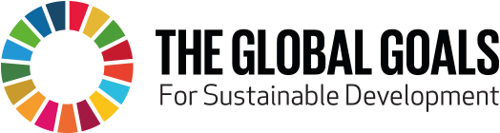 | CHV 2O5: Culminating Activity: Exploring Global Goals:

The introduction to the United Nations website globalgoals.org states that: “In 2015, world leaders agreed to seventeen goals for a better world by 2030. These goals have the power to end poverty, fight inequality and stop climate change. Guided by the goals, it is now up to all of us, governments, businesses, civil society and the general public to work together to build a better future for everyone.”
Here is their infographic:
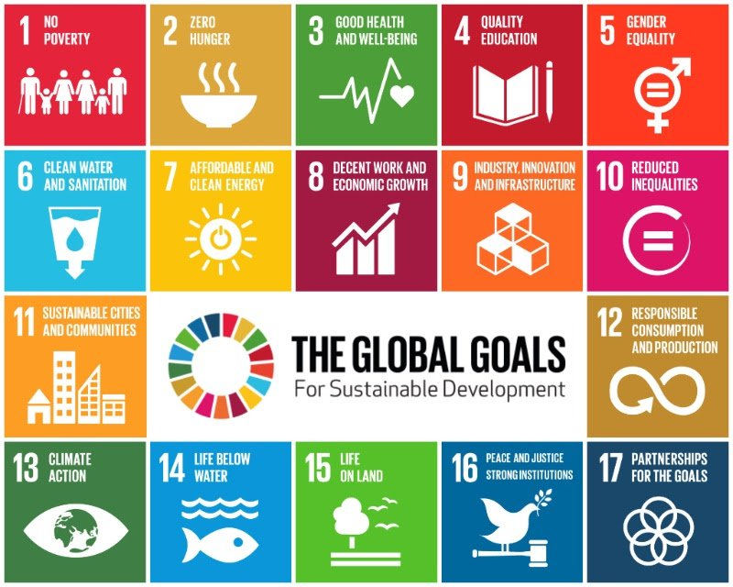
Before we begin, explore the website globalgoals.org, specifically the section titled “The World in Action”. Of all the projects listed there, your task is to identify your favourite, based on any criteria you choose. Then, note five reasons in support of your choice.

The Passion Project:
The final, culminating task of our civics course will involve the creation of a passion project that sets out to move the world closer to achieving one of the UN Global Goals. This project can be as large or small as you see fit, and can be impactful on any scale.
In short, by the time this project is finished, you will have created a something or artifact which creates some kind of progress towards achieving one of the seventeen UN Global Goals. As well, you will share this project in a formal way, both with the class as a whole and with other students.
That that there are a wide variety of options that your artefact could take, but a poster is not one of them.

Part I: The Brainstorming Journal:
The first phase of this culminating task is the writing of a journal. It will be two pages, double-spaced in length. It will answer the following questions:
- Of all seventeen goals, which one have you chosen? What was the reasoning behind this choice?

- How do you think you can create improvement in regards to your passion project? In your mind, what do you see your finished project “looking like”?

- Whom do you know, and in what context do you know them, that could help you take this project from conception to completion?

- What specific, practical skills do you have that can help this project be successful? For example, if you are going to build something, what are some of your talents/experiences as a builder? If you are going to create something artistic, what is your prior knowledge/skill set that will help this go well?
Journals, which will have a weight factor of one, will be marked based on the following criteria:
 | Level I | Level II | Level III | Level IV
Global Citizenship: Does the journal indicate an understanding of the Global Goal chosen? | The journal does not indicate an understanding of the Global Goal chosen | The journal indicates an understanding of the Global Goal chosen to a limited extent | The journal indicates an understanding of the Global Goal chosen well | The journal indicates an understanding of the Global Goal chosen excellently
Learning To Learn: Does the journal indicate an understanding of personal, transferrable skills? | The journal does not indicate an understanding of personal, transferrable skills | The journal indicates an understanding of personal, transferrable skills chosen to a limited extent | The journal indicates an understanding of personal, transferrable skills well | The journal indicates an understanding of personal, transferrable skills excellently
Communication: Does the journal communicate effectively in written form? | The journal does not communicate effectively in written form | The journal communicates effectively in written form to a limited extent | The journal communicates effectively in written form well | The journal communicates effectively in written form excellently

Part II: The Process: Research:
In this phase of the passion project, your task is to gather as much key information about your Global Goal as possible. Eventually, all of this information will be edited down to five vital details. This information will be placed in the following chart, which will be handed in:
Name: _________________________________________________________________
Global Goal Chosen: ____________________________________________________
One piece of information, which includes numerical data, which shows why improvement in my Global Goal is vital to the local community:
______________________________________________________________________________________________________________________________________________________________________________________________________________________________________________________________________________________________________________________________________________________________________________________________________________________________________
Source of “Local Community Data”, Cited in Chicago Style:
______________________________________________________________________________________________________________________________________________________________________________________________________________________________________________________________________________________________________________________________________________________________________________________________________________________________________
One piece of information, which includes numerical data, which shows why improvement in my Global Goal is vital to the nation as a whole:
______________________________________________________________________________________________________________________________________________________________________________________________________________________________________________________________________________________________________________________________________________________________________________________________________________________________________
Source of “National Importance Data”, Cited in Chicago Style:
______________________________________________________________________________________________________________________________________________________________________________________________________________________________________________________________________________________________________________________________________________________________________________________________________________________________________
One piece of information, which includes numerical data, which shows why improvement in my Global Goal is vital to the world as a whole:
______________________________________________________________________________________________________________________________________________________________________________________________________________________________________________________________________________________________________________________________________________________________________________________________________________________________________
Source of “Global importance Data”, Cited in Chicago Style:
______________________________________________________________________________________________________________________________________________________________________________________________________________________________________________________________________________________________________________________________________________________________________________________________________________________________________
Data Collection, which will have a weight factor of one, will be marked based on the following criteria:
 | Level I | Level II | Level III | Level IV
Global Citizenship: Does the data table indicate an understanding of the scope of the Global Goal chosen? | The data table does not indicate an understanding of the scope of the Global Goal chosen | The data table indicates an understanding of the scope of the Global Goal chosen to a limited extent | The data table indicates an understanding of the scope of the Global Goal chosen well | The data table indicates an understanding of the scope of the Global Goal chosen excellently
Critical Thinking: Does the data table indicate an understanding of quality, applicable, numerical data | The data table does not indicate an understanding of of quality, applicable, numerical data | The data table indicates an understanding of quality, applicable, numerical data to a limited extent | The data table indicates an understanding of quality, applicable, numerical data well | The data table indicates an understanding of quality, applicable, numerical data excellently
Communication: Does the data table communicate effectively in written form? | The data table does not communicate effectively in written form | The data table communicates effectively in written form to a limited extent | The data table communicates effectively in written form well | The data table communicates effectively in written form excellently

Part III: The Product: Artifact:
As you are working on your something or artefact, you will keep a series of brief video journals detailing your progress throughout this task. These video journals will be presented alongside your finished product.
Your videos will involve three of the following five topics:

- A “progress so far” video
- A “challenge I need to overcome” video
- A “great piece of feedback I plan to use” video
- A “one more day and then I’m done” video
- An “I’m finished and this is how I feel it went” video

Videos, along with work on the project itself, may be done at home and/or during our Maker Space time in the Library Learning Commons. Videos should only be around thirty seconds to one minute in length. You will produce and upload a total of three videos.

Note that you may need to seek “outside experts” if you need help with things like sewing, welding, woodcutting, etc. that you lack expertise in. Refer to our “Skills Inventory” if you need help. Or, ask outside of our “school bubble”.

Each Progress Video, which will have a weight factor of one, will be marked based on the following criteria:
 | Level I | Level II | Level III | Level IV
Critical Thinking and Problem Solving: Do the videos demonstrate thoughtful reflection on the product being created? | The videos do not demonstrate thoughtful reflection on the product being created | The videos demonstrate limited thoughtful reflection on the product being created | The videos demonstrate good thoughtful reflection on the product being created | The videos demonstrate excellent thoughtful reflection on the product being created
Creativity: Do the videos demonstrate new discoveries, concepts, and/or ideas? | The videos do not demonstrate new discoveries, concepts, and/or ideas | The videos demonstrate limited discoveries, concepts, and/or ideas | The videos demonstrate good discoveries, concepts, and/or ideas | The videos demonstrate discoveries, concepts, and/or ideas
Global Citizenship: Do the videos explore contributions to local and global initiatives that make a difference? | The videos do not explore contributions to local and global initiatives that make a difference | The videos explore contributions to local and global initiatives that make a difference to a limited extent | The videos explore contributions to local and global initiatives that make a difference well | The videos explore contributions to local and global initiatives that make a difference excellently
Communication: Do the videos express ideas and use the medium well? | The videos do not express ideas and use the medium well | The videos express ideas and use the medium to a limited extent | The videos express ideas and use the medium well | The videos express ideas and use the medium excellently
Artefacts, which will have a weight factor of three, will be marked based on the following criteria:
 | Level I | Level II | Level III | Level IV
Critical Thinking: Does the artefact show careful understanding of the nature of the Global Goal? | The artefact does not show carful understanding of the nature of the Global Goal | The artefact shows limited, careful understanding of the needs of the nature of the Global Goal | The artefact shows strong, careful understanding of the needs of the Global Goal | The artefact shows outstanding, careful understanding of the Global Goal
Global Citizenship: Does the artefact have potential to assist with progress towards the Global Goal? | The artefact does not have potential to assist with progress towards the Global Goal | The artefact has limited potential to assist with progress towards the Global Goal | The artefact has strong potential to assist with progress towards the Global Goal | The artefact has excellent potential to assist with progress towards the Global Goal
Creativity: Does the artefact offer unique ideas and solutions | The artefact does not offer unique ideas and solutions | The artefact offers unique, creative solutions to a limited extent | The artefact offers some unique, creative solutions | The artefact offers very unique, creative solutions
Self-Directed Learning: Does the artefact demonstrate ability to acquire knowledge or skills as needed? | The artefact does not demonstrate ability to acquire knowledge or skills as needed | The artefact demonstrates ability to acquire knowledge or skills to a limited extent | The artefact demonstrates ability to acquire knowledge or skills well | The artefact demonstrates ability to acquire knowledge or skills excellently

Part III: The Product: Project Fair:
Now that your project is completed, you will have the chance to share it. The format for this sharing will be a “Project Fair” in our Library Learning Commons. Students from a different class will visit each of the artefacts, and you’ll have the chance to tell them about it. This sharing will be largely informal, and the class visitors will offer their feedback and insights in the future.

Bibliography:
- "The Global Goals." The Global Goals. Accessed June 28, 2018. https://www.globalgoals.org/.

