“The Story Behind The Stamp”
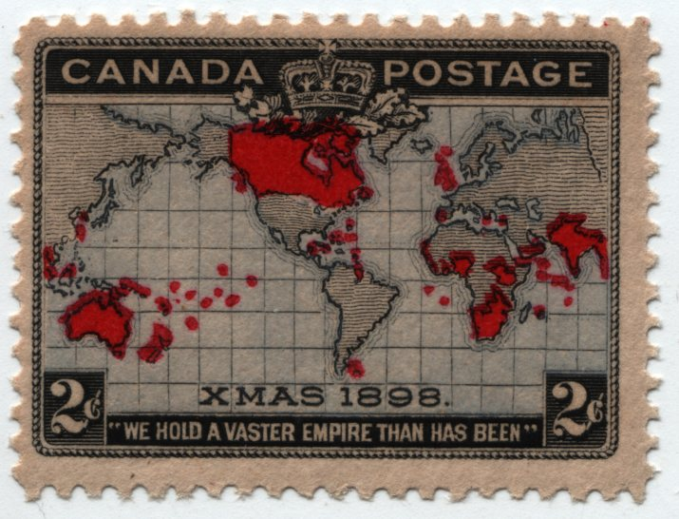
What does this stamp, the first “Christmas stamp” in the history of the world, reveal about Canadian identity in 1898?

