Big Idea: Citizenship is About More Than You Were Born: | 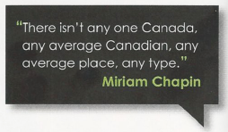

What Does It Mean To Be a Canadian Citizen?

People are citizens of a country either by birth or by choice. You may be a Canadian citizen because you were born in Canada or because your parents are Canadian. Or, you may have immigrated to Canada because you had to, or wanted to, and chose to apply for citizenship. But is that all there is to it? Does living in a country, in and of itself, make someone a “citizen”?

What links individuals together most strongly are common interests and values – a sense that we belong. Ultimately, it is our sense of belonging that defines how much we participate in our society, too. Canada has one of the most diverse populations in the world. So, what connects us? What makes us feel like we belong?

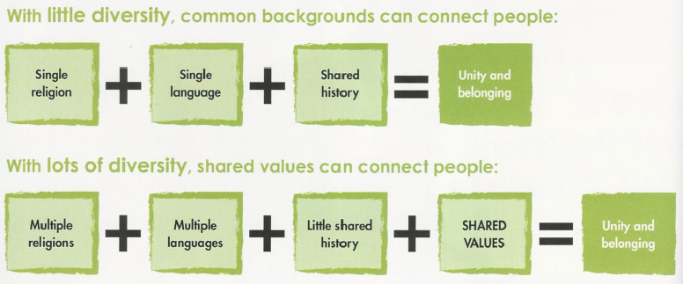

Analysis Questions:

- Which of the images, quotes, and words below unite Canadians? Is anything missing? Is any of it untrue?

- Why might there be so many different views about what it means to be Canadian?

- Do you feel like you have a place in Canada? What does being a Canadian citizen mean to you?

What is Citizenship?

Legally, a citizen is a person who has fulfilled the requirements of citizenship and is an official member of a country. Citizens belong to their country, but a country also belongs to its citizens. Ideally, the relationship is mutually beneficial. Citizens benefit by living in an organized society with governments that exist to help them succeed in life. In turn, a country becomes stronger when citizens create prosperity, jobs, and a vibrant culture. As citizens and their communities flourish, so does their country, and vice versa.

Citizenship is A Relationship:

Essentially then, citizenship is a relationship. In democracies like Canada, all citizens have rights and freedoms that are protected by laws that everyone must obey. Responsibilities are not set out by laws, but are duties citizens all agree to fulfill. Citizenship is based on the understanding that with rights come responsibilities. Fulfilling those responsibilities is for everyone’s benefit.

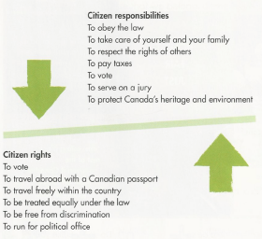

The Oath of Canadian Citizenship:

I swear (or affirm) that I will be faithful and bear true allegiance to Her Majesty Queen Elizabeth II, Queen of Canada, Her Heirs and Successors, and that I will faithfully observe the laws of Canada and fulfil my duties as a Canadian citizen.

Analysis Questions:

To apply for citizenship, you must have lived in Canada for at least three years, know English or French, understand the responsibilities of citizenship, not be a criminal, and take the Oath of Canadian Citizenship.

- Is this a reasonable expectation? If not, suggest one addition or removal.
- Are you satisfied with the Oath of Citizenship? If not, suggest one addition or removal.

- In some countries, military service is compulsory for citizens. In Canada, joining the military is voluntary. Do you think all Canadian citizens should have to serve in the military?

What Do We Mean By Active Citizenship?

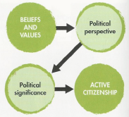

“We do not say that a man who takes no interest in politics is a man who minds his own business; we say that he has no business here at all” – Pericles, Athenian Leader, (495 BCE – 429 BCE)

We all make personal decisions about the best way to live our lives and about the kind of person we want to be. Our lives are unique because we are unique. The same is true of citizenship. You can be a good citizen in a thousand different ways.

But, good citizens do share one thing in common – they are active. Active citizens are informed, engaged, and participate in their communities. How you choose to be engaged and to participate in up to you.

Thinking About Active Citizenship:

Active Citizenship can also mean “taking action” – doing something in a large or small way in your community. Civic action works best when it reflects your beliefs and values, is informed, and had a clear objective. It should reflect a person’s values and beliefs and a clear objective. If you don’t know what your objective is, it’s less likely you will see good results. You can use the chart below to help you think about how you will be an active citizen.

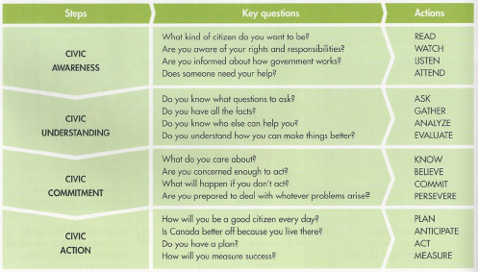

Personal Perspectives on Citizenship:

Active citizenship is not a competition to see who is the best citizen. We can and do honour those Canadians who achieve extraordinary results. But the greatness of our country is measured by the little things that millions of Canadians do every day.

If Canada is prosperous, it’s because its citizens are law-abiding. If there is injustice, then Canadians need to work for change. Everything Canada is, and will be, is a reflection of who its citizens are and what they care about.

So, citizenship is a very personal thing. Being a citizen is not just what is expected of you, but what you choose to do, or not do, every day.

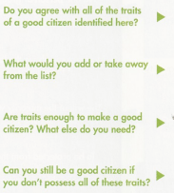 | 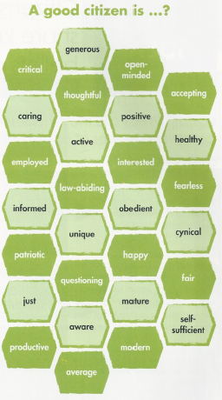

Analysis Questions:

- How active do you need to be in order to be a good citizen? Is just being a good person good enough?

- How would a person’s beliefs and values affect their idea of what makes a good citizen? Can you think of any examples?

- Do you think that you are a good citizen? Why or why not? How could you be a better one?

