Who is Abby Hoffman?
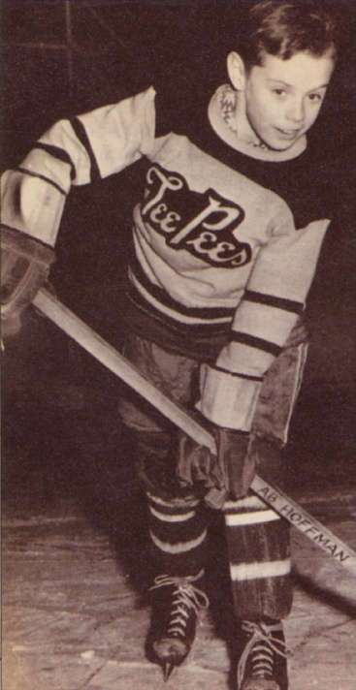
In 1956, a nine year old defenseman named Ab Hoffman made headlines across North America.
Ab was actually Abigail, better known as Abby, a girl who dearly loved sports and the game of hockey. Girls were not allowed to play on boy’s teams at that time. Though women's hockey dates back nearly as long as hockey itself, Hoffman had no other opportunities to play.
Abby had managed to disguise her gender through the season by dressing in her equipment at home, and by wearing her hair in a boyish fashion. She played well, too, earning all star status.
Her cover was blown when the team's season came to an end. The team was entering a season ending tournament which required her to produce her birth certificate, clearly displaying her gender.
The hockey league proceeded to ban Abby from playing. Determined to play, Abby and her family took the issue to the Ontario Supreme Court, but the courts ruled in favour of the league.
Her battle caught the attention of media across North America, including Time and Newsweek, and established the spotlight to give young girls the opportunity to play hockey. She may not have realized it at the time, but her battle helped her become one of the most influential women in hockey and Canadian sport.
At the age of 15, Hoffman told her story to CBC radio.
Unable to play hockey, the undeterred Abby went on to a distinguished career in track and field, competing in four Olympic Games. She was the Canadian flag bearer for the opening ceremonies of the 1976 Olympic Games in Montreal.

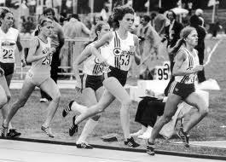
In 1982 the Ontario Women's Hockey Association remembered Hoffman's struggle to play by creating the Abby Hoffman Cup - the first national women's tournament.

