Exploring Heritage Property: 1656 Hyde Park Rd
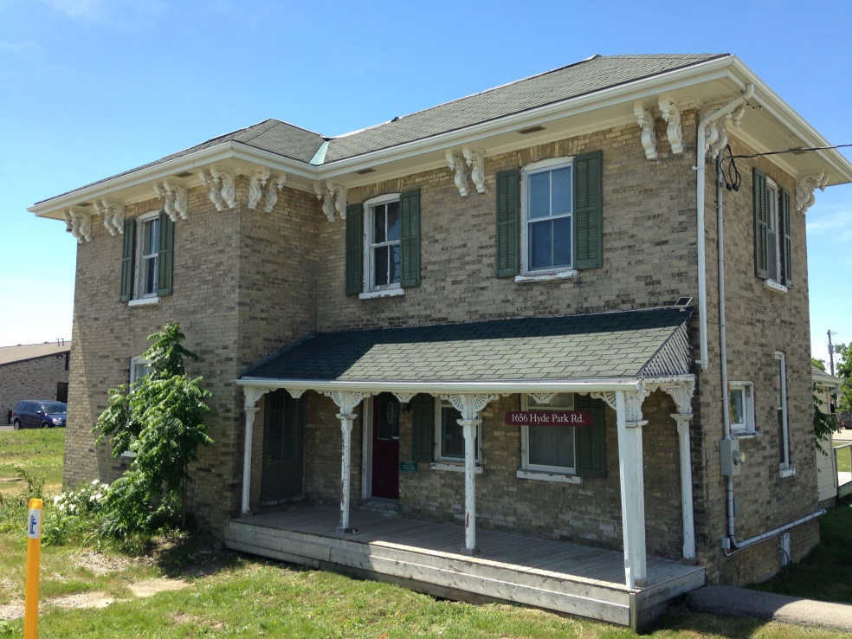
You may have noticed this house on your travels. The address is 1656 Hyde Park Road, which is between Gainsborough Road and North Routledge Park. It is a very unique property, and in many ways, it feels very out of place in modern London, Ontario.
Part of the reason it feels out of place is because this home was built in 1818. It is associated with the Routledge family, and was likely built for Robert Routledge, who was around fifty-six when the home was built. Robert was a farmer, who immigrated from England, and defined himself as an Anglican Farmer. Robert Routledge and his family were part of an immigrant group known as “Talbot Settlers”. This group came to Canada the same year that the home was built.
The property's style and form is increasing rare in Hyde Park and the City, and is reflective of the rural village past of Hyde Park.

On Monday, April 25th, 2016, the City of London made the request that 1656 Hyde Park Road be designated as a heritage property. This request was made in response the owner of the property, Hyde Park Investments 2015 Incorporated, to demolish the property.
Here are some key details about 1656 Hyde Park, as noted by Mr. Kyle Gonyou, Heritage Planner, City of London:
- The property has direct associations with the Routledge family, the founding family of Hyde Park, who are part of a group known as “Talbot Settlers (1818). Therefore, 1656 Hyde Park Road has “direct associations with a theme, event, belief, person, activity, organization or institution that is significant to the community”

- The property is “important in maintaining the village character of Hyde Park as a historic, rural settlement area”

- 1656 Hyde Park is “historically linked to the history and development of Hyde Park”

It should be noted that, in the application for demolition, the owner of the property noted that: “The building appears to be in a poor state of repair as noted in the report and will require a large investment to repair completely. There appears to be no immediate danger in terms of the structure failing so that is not a concern.”

Although some of the properties on Hyde Park Road look like houses, all the properties on the street are zoned by the City of London as Business/District/Commercial (BDC) properties.

The farmhouse is on a property that is 90,000 square feet, two acres, or 27,432 square metres.

Analysis:
- Now that you have learned a little about 1656 Hyde Park Road, your group will write five questions that, if you had the answers to them, would allow you to become an “expert” on this property.

