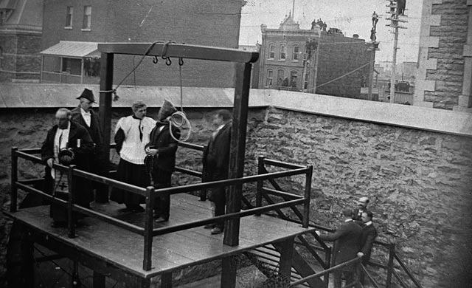
In your small group, begin by describing what you see in the image above.

On March 21st, 1902, Stanislaus Lacroix was executed in Hull, Quebec, for killing his wife and a neighbor. Although executions were private, you can see onlookers in the background trying to see into the jail yard.
What does this photograph suggest about the moral values of society at that time?

