Getting Our Ducks in a Row!

You are the newest Member of Provincial Parliament. You have been asked by the Premier to make sure that “all our ducks are in a row” leading up to the upcoming vote in the Legislature on the issue of environmental protection. The Premier is concerned that the vote might not go through, as the last election resulted in a minority government for the Premier. The Premier would like you to map out the campaign to lobby the people.

Task:

Brainstorm a list of the ways that the government could influence the people of Ontario to support this new policy on environmental protection. The Premier is going to introduce a law that will:

- place limits on the number of and weight of bags you can place out for garbage collection based on your type of residence
- place a fine of $20 for each bag that is over the weight limit
- place a fine of $25 for each bag that is over the household limit

Use the following organizer to help you prepare for your meeting with the Premier.

For each of the blank boxes, indicate a possible action that the government could take to raise interest in and support for this new policy.
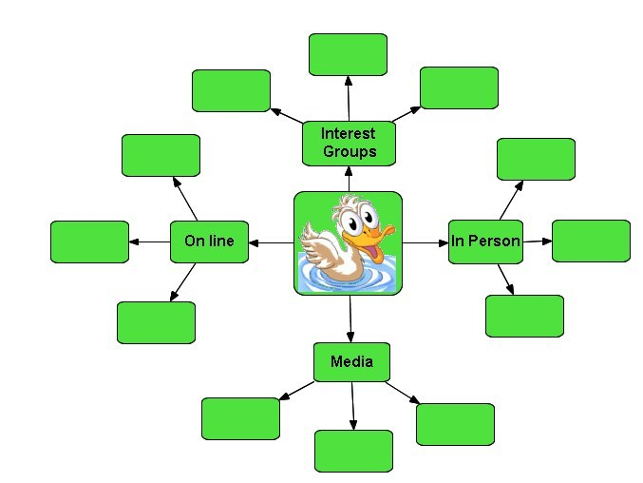
Printed Paper Garbage Bags delivered to residences
TV commercials to run during prime time
Work with Waste Management Companies

