Life During The Great Depression:

LIFE IN MOOSE JAW
"My name is Orville Walker and I am a grain farmer near Moose Jaw. I‘ve enjoyed some pretty good years. Yep, I cleared over $3,000 in 1928. Things looked pretty dang good. So I went out and bought a new tractor and a new threshing machine. Of course, I had to borrow most of the money to buy those contraptions. Now, things don’t look too hot. The politicians tell us that countries in Europe have put taxes on our wheat. The price of our grain is too high and we can’t sell it outside of Canada."

"When it rains, it pours, except out here in Saskatchewan, we ain’t seen rain for a long time. The land is drying up and a lot of our good top soil is flying off in the wind. Me and the missus may have to sell the farm, except no one wants to buy the place."

Life During The Great Depression:

LIFE IN RED DEER
"My name is Jane Myers and my husband, Joe, and I run a General Store in Red Deer, Alberta. I’ll tell you that the year 1931 has been one tough year. We sell to farmers mostly, and they don’t have no more money to spend. With the bad harvests, farmers 'round here are in debt up to their noses. They come into our store and buy stuff on credit. We used to give them credit, but no more! Everybody owes us money! Yeah, we can’t be a charity. We have to pay our suppliers and we don’t have the money to do that anymore. Almost all of our regular customers owe us big time. Joe worries that we will never get back the money owed to us."
"Not that our prices aren’t low. You can buy a good pair of coveralls for 50 cents, but no one can afford to buy them. I’m no economist, but I don’t see why the government don’t give everybody some money, so people can start buying again. Hey, why don’t the government send everyone a cheque for, say, $25.00 each month? They better do something soon, or Joe and I will have to sell the store. Wait a minute! Would anybody have the money to buy the store? Would anybody even want the store?"

Life During The Great Depression:

LIFE IN PRINCE RUPERT
"The name is Dan Daniels. I haven't been able to find work for over a year. They released me from the pulp and paper mill in Prince Rupert because no one can afford to buy the darn newsprint. I‘ll do anything for a pay cheque."
"I got a wife and five kids. The landlord has been pretty good about the rent but I got seven mouths to feed, so we end up going to soup kitchens run by the churches. The people at the welfare office make you feel like dirt. You practically have to crawl to get your weekly handout. You know, I hate the scums that run this country."
"I hear there’s work in Ontario. Tomorrow, me and a bunch of guys are jumping on a freight and heading east. The wife tells me she will look after the kids and continue to beg at the relief office -- at least until I send her money from that job in Ontario."

Life During The Great Depression:

LIFE IN MONTREAL
"My name is Marie Marcotte. I am a widow, and in this year of 1931, I am raising four kids by myself. I live in Montreal and I used to work in a clothing factory. I used to make shirts for ten hours a day and I would get paid for “piece work.” This means that I would be paid based on the number of shirts I could sew in a day. If I worked really hard, I could make $4.00 a day!"
"Well, that was last year. About six months ago, they cut my wages to $3.00 a day, and then they cut the number of days I worked. Now, I could still get by because prices have been dropping. I used to pay 15 cents for a dozen eggs and now I get them for 8 cents a dozen. Milk used to be 10 cents a quart, and now I get it for 6 cents a quart."
"Well, it ain’t doing me much good anymore. Last week, I got laid off from my job. With no money coming in, what good are these low prices?"

Life During The Great Depression:

LIFE IN OSHAWA
"My name is Archie Peters. In this year of 1931, I count myself lucky because I got a job. I work in the car plant in Oshawa, but how long will my luck last? Every day there are layoffs because car sales are way down. The work on the assembly line requires a lot of concentration. If you slack off, they “write you up” and you can expect to be on the “pink list” for the next batch of firings."
"We’ve had wage cuts three times in the last two years. The managers keep demanding more and more effort. If you complain, you’re labelled an “agitator” and you can expect to get canned, so you keep your mouth shut. Lots of people would give their eye teeth to have my job. There is talk about forming a union, but what good is a union if management fires all of us, as they have threatened to do?"

Life During The Great Depression:

LIFE IN GLACE BAY
"My name is Annie McNeil. My John used to work in the big mine here in Glace Bay. It is now 1931, and we’ve had a rough go of it the past few years. The coal mine is owned by outsiders, and they said they were having trouble selling coal in Europe and the United States. They told the men that they would have to take a 30% wage cut. The miners said, “no way” and there was a series of awful strikes."
"That was a few years ago. Now they have laid off my John. He don’t know what else to do. His father was a miner and so was his father’s father. There ain’t no other jobs ‘round here. I used to clean houses, but people can’t afford to hire me anymore, even at 50 cents a day. My John is a brave man. He’s seen friends killed in mine accidents. He would do anything to get a job again to support me and the four little ones. He hates asking for help from the parish priest, but what else are we going to do?"

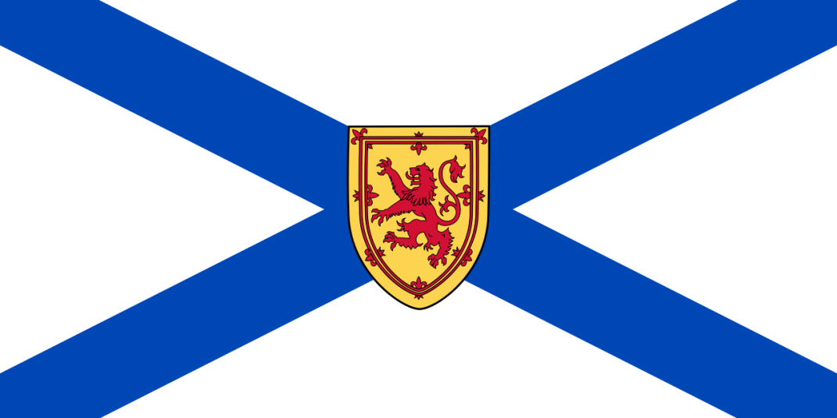

Life During The Great Depression:

LIFE IN FLIN FLON
"My name is Donny McLaughlin and I’m hopping mad. I’m a teacher in Flin Flon and my 1931 salary’s been cut from $1200 to $700.00 a year. How can I support a family on $700.00 a year? One of my five kids is real sick with polio, and it tears me up inside that we can’t afford medical care."
"My wife got so fed up that she wrote a letter to Prime Minister Bennett, complaining. She got a nice reply and a five dollar bill from the Prime Minister. We can sure use the five spot, but this handout doesn’t fix the big picture."
"We need a new political party in this country. We need a party which will spread out the wealth. Money should be taken from the very wealthy and given to the poor. We need a political party which will bring in government-supported health care. If this kind of political party was formed in Canada, I would be the first in line to vote for it."

Analysis Questions:
- What problems do the five characters that you listened to have in common? Give details.
- Select three of the characters and offer some solutions to their problems.
- In today's world, are there problems similar to the problems described by the personalities from the Depression period? If so, what are they?

