From Policy To Law: Canada’s Legislative Process:

“The day that Parliament becomes a slot machine into which you drop a slug and out comes legislation, freedom ends.” – John Diefenbaker, former Prime Minister of Canada

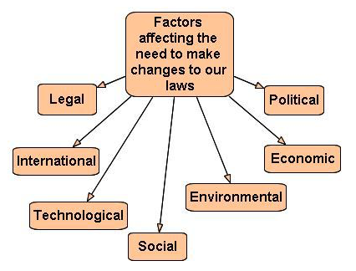

The process by which laws are made can be broken into two stages: the pre and legislative processes. In the pre-legislative process governments and political organizations are researching the needs of their communities and developing their platforms.

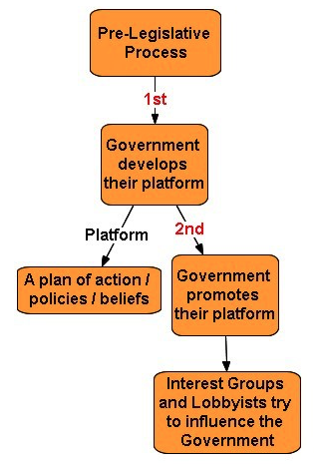

The legislative process is similar in all levels of government – examine the following outlining the process used at the federal level of government.
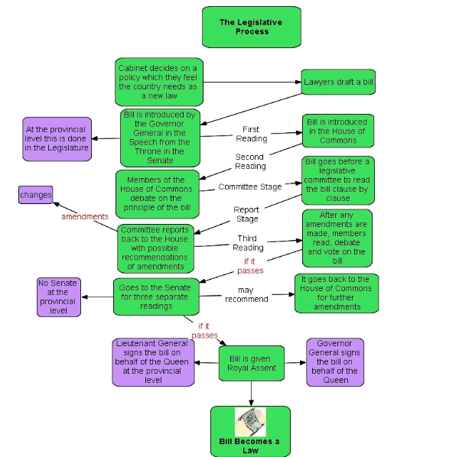
At the municipal level, laws, known as bylaws, go through a similar process whereby the councillors develop policy, work with committees and introduce bills at council. Bylaws are passed by a council through a simple majority vote.

