Vibram FiveFingers Lawsuit Settlement To Pay $8-9 Per Claim, Report Says

By Kurt Bresswein

November 18th, 2014

http://bit.ly/2aHqZv6

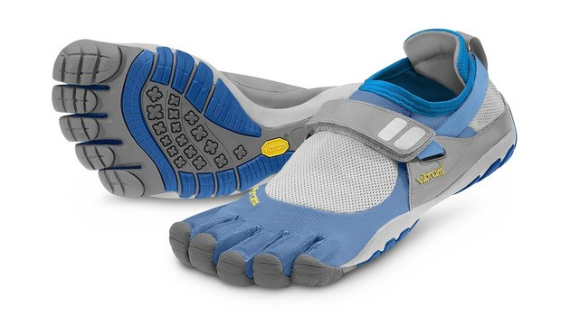Footwear manufacturer Vibram stands to pay more than 150,000 claims, worth between $8 and $9 each, in a class-action lawsuit settled over its FiveFingers shoes, Emmaus-based Runner's World magazine reports on its website.
Filed in federal court in Massachusetts, Bezdek vs. Vibram USA is still pending final court approval.
Valerie Bezdek in 2012 brought the case against Vibram, claiming the company deceived consumers by advertising the footwear could reduce foot injuries and strengthen foot muscles without basing those assertions on scientific evidence, Runner's World reports.
Vibram agreed in May to a $3.75 million settlement to end the case, with CEO Mike Gionfriddo saying the company does not admit fault but wanted to stem legal costs over the shoes, according to the report.
According to Runner's World, the court's independent case administrator received 154,927 timely claims filed for FiveFingers purchased between March 21, 2009, and May 27, 2014.

