Summary of Chub v. HudBay (Lawsuit Regarding The Shooting of German Chub Choc)

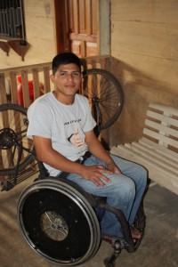

The lawsuit alleges that in the afternoon of September 27th, 2009, German Chub Choc, a young father, was shot at close range in an unprovoked attack by the head of security personnel for HudBay’s Fenix Mining Project. As a result of the shooting, German Chub suffered catastrophic and life threatening injuries. He survived the attack, but is now paralyzed and no longer has use of his right lung.
The lawsuit alleges that the brutal and arbitrary shooting of German Chub was caused by the negligent management of HudBay Minerals both in Canada and in Guatemala. In particular, the lawsuit alleges that HudBay Minerals negligently authorized the reckless and provocative deployment of heavily armed security personnel into Mayan Q’eqchi’ communities on September 27th, 2009, and negligently authorized the excessive use of force by its security personnel in response to Mayan Q’eqchi’ communities that were opposed to the illegal occupation of historic Mayan land.
HudBay Minerals knew that it was operating in a country with extreme levels of violence and low levels of accountability for such violence. The lawsuit alleges that HudBay Minerals knew that Fenix Mining Project security personnel had a track record of using violence in the past against the local Mayan communities that had opposed mining in their community, and knew that there was a very high risk that its security personnel would commit acts of uncontrolled violence in the future. The lawsuit alleges that despite this knowledge, HudBay Minerals continued to employ under-trained and inadequately supervised security personnel while failing to implement or enforce standards of conduct and oversight that would have adequately governed and controlled their conduct.
German Chub is suing HudBay Minerals for the catastrophic harms suffered by him as a result of the shooting.
Analysis Questions:
- Why, based on this article and on prior knowledge, is a Canadian company (potentially) legally responsible for the injuries to German Chub Choc?

- Prior to this incident, what are some potential steps that HudBay could have taken to prevent Mr. Choc’s injuries?

- Infer why Mr. Choc’s legal team would prefer to have his case heard in a Canadian court as opposed to a Guatemalan one.

