Canada’s Response to The Threat of War:
As events Europe, with Hitler’s aggressive policies, many Canadians asked why lives should be risked in another European war when Canada itself was not threatened.
Canada’s Policy of Isolationism:
Throughout the events of the 1930s, Canada practised isolationism, keeping out of affairs outside its borders. Prime Minister William Lyon Mackenzie King did not want Canada to become involved in another world conflict and had hoped that Britain’s policy of appeasement toward Hitler would be successful. WWI had deeply divided Canada on the issue of conscription, and Canadians had made many sacrifices in that overseas conflict. King knew that if he imposed conscription in this war, he and the Liberal Party would lose support in Quebec. Besides, Canada was just starting to come out of the dark years of the Depression. The economy was slowly improving and King did not want the country plunged back into debt.
King’s Response to Jewish Refugees:
While King knew that the Nazis were tyrannizing people, he maintained Canada’s isolationist policy. Like King, many Canadians believed that what was happening in Europe was a domestic issue that should not affect them. This attitude influenced Canada’s immigration policies and attitudes toward Jewish refugees fleeing persecution in Europe.
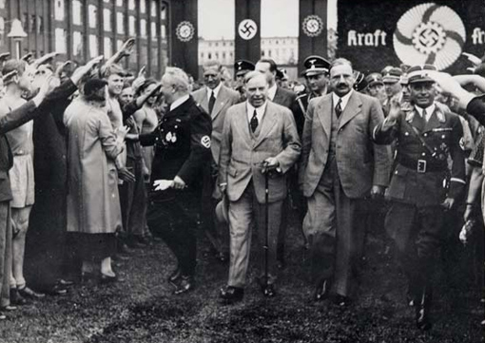
After meeting Hitler in Germany, Mackenzie King (centre) wrote the following in his diary on June 29th, 1937: “(Hitler) smiled very pleasantly and indeed had a sort of appealing and affectionate look in his eyes. My sizes up of the man as I sat and talked to him was that he is really one who truly loves his fellow man”
Anti-Semitism in Canada:
Some Canadians supported the dictators who had seized power in Europe of approved of Hitler’s policies and hatred of Jewish people. In Quebec, some nationalists called for an independent Quebec with a pure French-Canadian population. Anti-Semitism in Canada during the 1930s was not restricted to extremists. It was shared by many in mainstream society, and it was reflected in newspapers and in general conversation.

The SS St. Louis:
Canada’s immigration policy and refusal to accept Jewish refugees had tragic consequences in 1939. The SS St. Louis left Hamburg, Germany, in May with 907 Jewish passengers desperately trying to escape persecution. The St. Louis was denied entry in Cuba, South America, and The United States. Canada was the passenger’s last hope. The Canadian government refused to let the St. Louis dock in any port because the passengers did not qualify as immigrants. The ship was forced to return to Europe. Tragically, many of the people later died in concentration camps during the holocaust.
Canadians Speak Out:
Many Canadians did not share the government’s anti-Semitic views, Cairine Wilson, Canada’s first female senator and chair of the Canadian National Committee on Refugees, spoke out against the banning of Jewish refugees from Canada. Prime Minister Mackenzie King was urged to offer the Jewish refugees sanctuary. In 1938, there were more than 150,000 Jewish people living in Canada. Rallies were held in many parts of the country in support of a more humane immigration policy. After the St. Louis incident, newspaper editorials also lashed out at the government:
This country still has the bars up and the refugee who gets into Canada has to pass some mighty stiff obstacles – deliberately placed there by the government … immigration bars … are undesirable … We are deliberately keeping out of this country people and money who would greatly add to our productive revenues. We are cutting off or nose to spite our face.
- Winnipeg Free Press, July 19th, 1939
Analysis Questions:
- Why did so many Canadians favour isolationism in the 1930s?

- How do you think Prime Minister Mackenzie King could form such a misguided opinion of Adolf Hitler?

- What is a refugee? (Hint: This answer needs to be inferred, it is not in the reading)

- In the reading, how/why can it be inferred that the concept of a “refugee” as we understand it today did not exist in 1939?

- In terms of the treatment of “refugees” prior to WWII, how was official government policy different from the popular view of many Canadians?

