The Moon Landing: A Decision-Making Simulation:

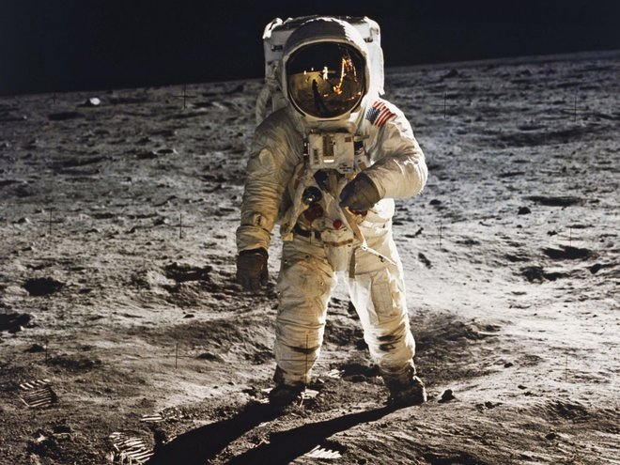

Introduction:

You are a member of a space crew scheduled to rendezvous with a mother ship on the lighted surface of the moon. However, due to mechanical difficulties, your own ship was forced to land at a spot 200 miles from the rendezvous point. During re-entry and landing, much of the equipment aboard was damaged and, since survival depends on reaching the mother ship, the most critical items available must be chosen for the 200-mile trip.

Fifteen items are listed as being intact and undamaged after landing. Your task is to rank
them in terms of their importance for your crew, to allow them to reach the rendezvous point. Place the number one by the most important item, the number two by the second most important, and so on through to number fifteen for the least important.

Instructions:

- Provide a ‘moon landing ranking chart’ for every member of your group.

- Ask each young person to take ten minutes to decide their own rankings, and record the choices in the left-hand column, which is labelled My Ranking

- Invite everyone to get into groups of 3-4. Discuss their individual choices and refine their rankings based on the collective thoughts of the team. Record the group rankings in the second column, which is labelled Team Ranking

- The correct answers were compiled by a team of scientists and engineers at NASA. Display the NASA ‘expert’ rankings on a PowerPoint presentation. Compare your individual and group answers with the correct answers and determine a score.

- For each item, mark the number of points that your score differs from the NASA ranking and then add up all the points. Disregard plus or minus differences. The lower the total, the better your score.

Moon Landing Ranking Chart:

My Ranking | Salvaged Items | Team Ranking
 | Box of Matches
 | Food Concentrate
 | 50 Feet of Nylon Rope
 | Parachute Silk
 | Two .45 Caliber Pistols
 | One Case of Dehydrated Milk
 | Two 100-Pound Tanks of Oxygen
 | Stellar Map
 | Self-Inflating Life Raft
 | Magnetic Compass
 | Five Gallons of Water
 | Signal Flares
 | First Aid Kit Containing Injection Needles
 | Solar Powered FM Receiver
 | Portable Heating Unit
Score |  | Score

