Source III:
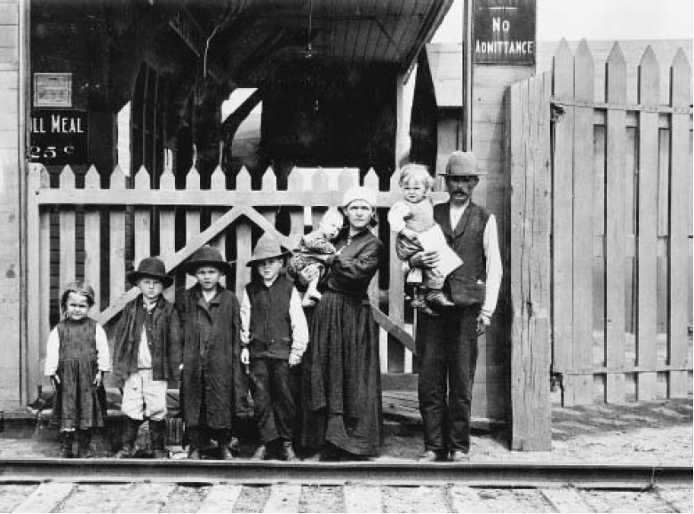
Galicians at an Immigration Shed in Quebec City

