London Police Officer’s Use of Cell Phone While Driving Legal
By Hala Ghonaim, The London Free Press

Wednesday, July 20th, 2016

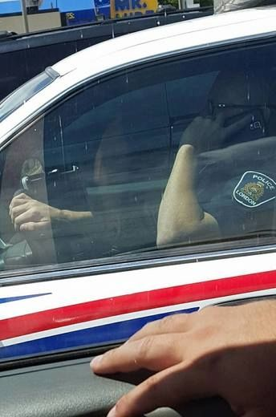

This London police officer was spotted on the phone behind the wheel of his cruiser Sunday, July 17th, 2016 near the corner of Wonderland Road and Oxford Street.

He was in his car, with one hand on the wheel, the other holding a cellphone to his ear, a London police badge on his shoulder.

It’s an image that went viral on social media Sunday, gathering more than 3,500 shares on Facebook, after getting posted online.

“Nobody will ever take distracted driving seriously if the public continue to see this,” said Natasha Anseeuw, who was passing through London at the time of the incident.

She noticed the officer on his cellphone at about 1 p.m. Sunday at the intersection of Wonderland Road and Oxford Street.

A passenger in her car snapped the photo, saving Anseeuw $500 to $1,000 in fines if she had pulled out her own cellphone.

If convicted of distracted driving, a driver may be fined as much as $1,000 fine and get up to three demerit points. Drivers who endanger others because of any distraction, including eating on the road, may face a $2,000 fine, six demerit points, a jail term of six months, and a two-year licence suspension, under the Highway Traffic Act.

However, the same doesn’t apply to the officer in the photo.

“There is an exemption for law enforcement officers when it comes to hand-held devices in relation to using them while on duty,” Const. Sandasha Bough reminded Londoners in a reply to concerned citizens who reached out to police regarding the online post.

Police officers aren’t the only ones who are given the green light. Several government officials, park wardens, conservation officers, and emergency workers also are exempt from the hands-free cellphone law.
London police are allowed to use hand-held devices during rare circumstances such as communicating with a complainant, said Bough.

“Yes, we’re trying to multi-task and we do it on a daily basis,” she said. “But we still encourage our (officers) to pull off the roadway and park their vehicles.”

Bough said it's unclear if London police have not contacted the officer in the photo to determine the urgency of the phone call.

Regardless of the exemption, Anseeuw isn’t convinced.

“People learn from example. Monkey see, monkey do,” she said.

