The Cottingley Fairies:
In 1920, a series of photos of fairies captured the attention of the world. The photos had been taken by two young girls, the cousins Frances Griffith and Elsie Wright, while playing in the garden of Elsie's Cottingley village home. Photographic experts examined the pictures and declared them genuine. Spiritualists promoted them as proof of the existence of supernatural creatures, and despite criticism by skeptics, the pictures became among the most widely recognized photos in the world.
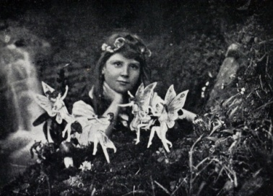
In July 1917, Frances and Elsie the pair asked to borrow the camera of Elsie's father, telling him they wanted to take a photo of the fairies they had been playing with all morning. Elsie's father laughingly agreed and showed them how to use the camera. An hour later the girls returned, declaring their project a success. And when Mr. Wright developed the plate that evening, he could see that there did indeed appear to be a fairy posing with Frances in the photo. However, he dismissed the girls' explanation, assuming the picture was some kind of trick. He asked Elsie why there appeared to be "bits of paper" in the photo.
Even when the girls took a second photo a little over a month later, showing Elsie with a gnome, the father treated the images as a joke and filed them away.
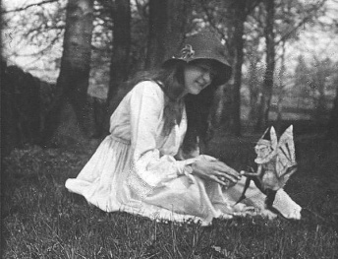
However, Elsie's mother, Polly Wright, had a stronger belief in the supernatural, and was more intrigued by the photos. In 1919, she attended a lecture on spiritualism and following it, she showed the photos to the speaker, asking him if they "might be true after all." The speaker brought the photos to the attention of Edward Gardner, a leader of the Theosophical movement, who in turn asked a photographer, Harold Snelling, to examine them. Snelling declared the photos were "genuine unfaked photographs of single exposure, open-air work, show movement in all the fairy figures, and there is no trace whatever of studio work involving card or paper models, dark backgrounds, painted figures, etc."
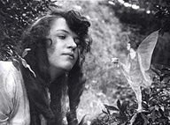
Once they had received this stamp of approval, the fairy images began circulating throughout the British spiritualist community, and soon came to the attention of Sir Arthur Conan Doyle, author of the Sherlock Holmes mysteries. Doyle was a passionate believer in spiritualism, and he latched onto the images, convinced they were conclusive photographic proof of the existence of supernatural fairy beings.
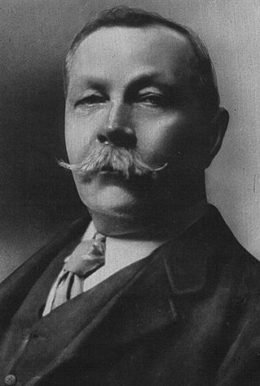
At Doyle's urging, the girls took three more pictures of fairies in August 1920. Doyle then wrote an article about the photographs that appeared in the December 1920 issue of The Strand Magazine, in which he passionately argued for the authenticity of the images. This article brought the photos to the attention of the wider public and sparked an international controversy that pitted spiritualists against skeptics.
Skeptics noticed many problems with the photos, in addition to the obvious one that the fairies look like bits of paper. For instance, in the first photo why is Frances not looking at the fairies? The girls claimed they were so used to the fairies that they often paid them no attention. And why does the second fairy from the left not have wings? In the second photo, why is Elsie's hand bizarrely elongated? In the fourth photo, why is the fairy dressed in the latest French fashions?
Despite these problems, the photos continued to attract believers. Much of this belief might be attributed to the context of the times. By the end of WWI, the English were emotionally bruised and battered by four years of unrelenting bloodshed. They seemed to be in need of something that would reaffirm their belief in goodness and innocence. They found this reaffirmation in the fairy photographs of Frances and Elsie.
It was not until 1978 that it was pointed out that the fairies in the pictures were very similar to figures in a children's book called Princess Mary's Gift Book, which had been published in 1915, shortly before the girls took the photographs.
Subsequently, in 1981, Elsie Wright confessed to Joe Cooper, who interviewed her for The Unexplained magazine, that the fairies were, in fact, paper cut-outs. She explained that she had sketched the fairies using Princess Mary's Gift Book as inspiration. She had then made paper cutouts from these sketches, which she held in place with hatpins. In the photo of Elsie and the gnome, the tip of a hatpin can actually be seen in the middle of the creature. Doyle had seen this dot, but interpreted it as the creature's belly button, leading him to argue that fairies give birth just like humans.

