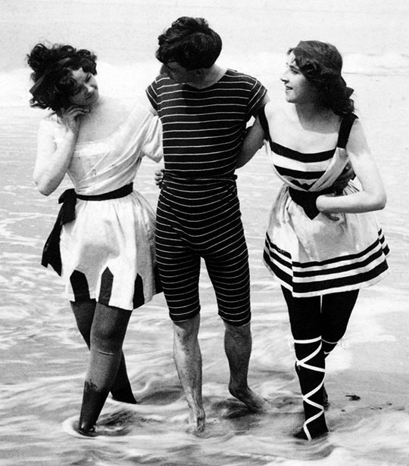

#VictorianBeachParty
- What prior knowledge of Victorian life does this photo confirm?
- What new inferences can we draw from this photo?

